Botanic Cottage Community Cook Club 29th April 2020

Banana and berry smoothies
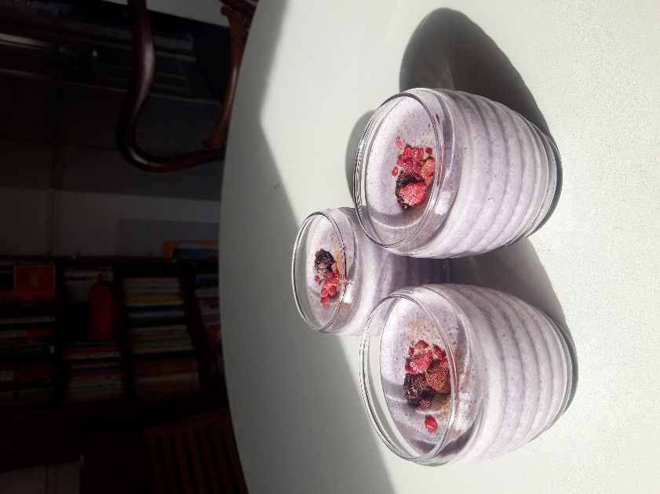

Per person
- 1 banana
- small handful berries – I used frozen raspberries and blueberries
- 1 heaped tablespoon oats
- ½ tsp ground cinnamon
- 200 ml milk (or plant-based alternative)
- 1 or 2 ice cubes (only if using fresh fruit not frozen)
You will need a blender for this recipe.
1. Add the fruit, milk, oats and cinnamon to your blender. Blend at a high speed until smooth. If your smoothie is too thick, add a little extra milk or water.
2. If you like, serve with a little extra cinnamon and extra berries as a garnish

