Botanic Cottage Community Cook Club 29th April 2020

Chocolate chip cookies
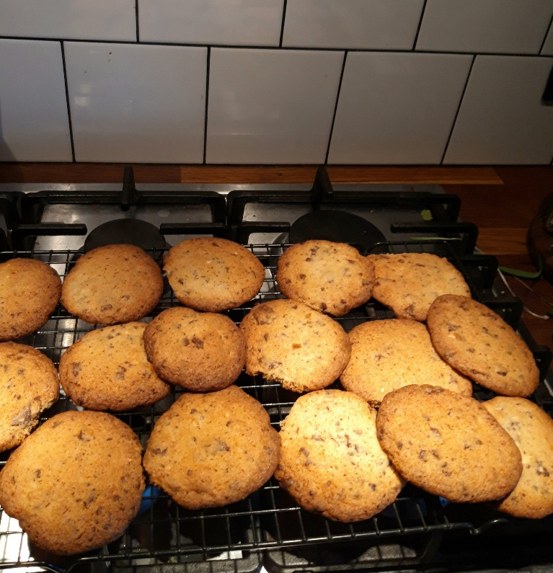

- 100g soft butter
- 1 egg
- 125g caster sugar
- 150g self-raising flour
- 80g chocolate, chopped into chunks. (Alternatively use nuts or raisins)
You will need a large bowl, two baking trays, baking paper, a wooden spoon, a cooling rack.
- Preheat the oven to 180 degrees.
- In a large bowl mix together the butter, sugar and egg until creamy and well combined.
- Stir in the flour and then add your chocolate chunks.
- Line two trays with baking paper.
- Using two spoons or your hands form the mixture into 16 balls. Put 8 on each tray, with space between them and squish them a little.
- Bake for 12-15 minutes until golden.
- Try to wait until they are cool before eating! Easier said than done, I know.

