Botanic Cottage Community Cook Club 29th April 2020

Halloumi and kale tabbouleh

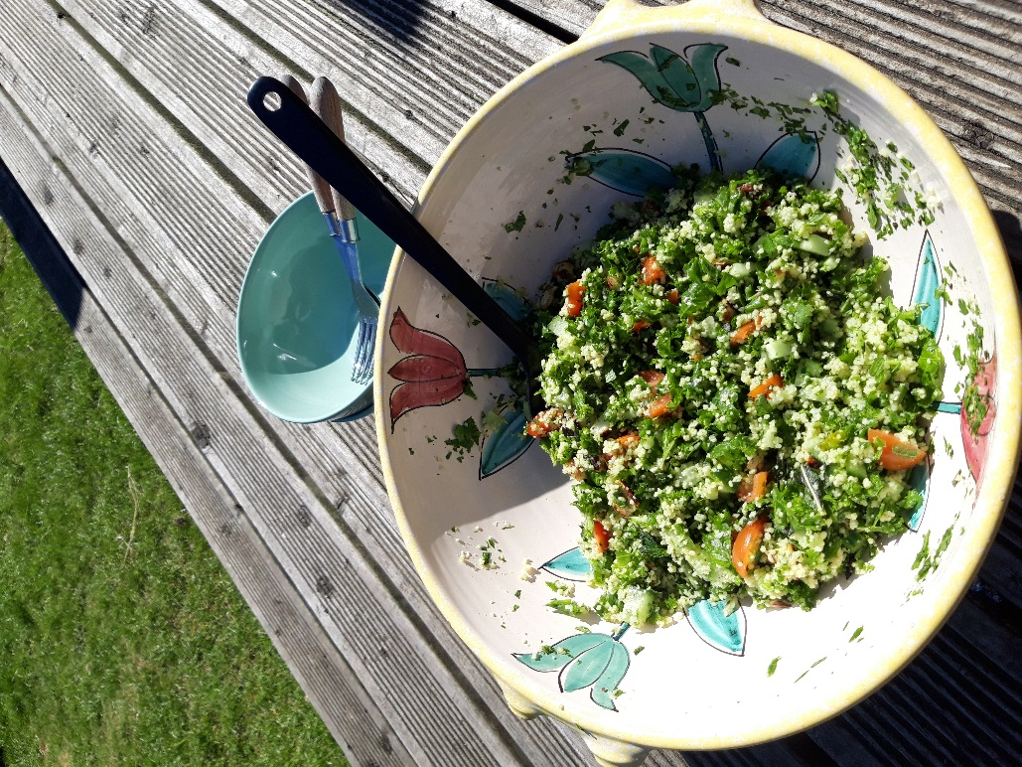

Serves 2
- 125g couscous
- 100g halloumi cheese (½ a packet)
- 2 tomatoes or a large handful of cherry tomatoes
- ½ a cucumber
- Large handful fresh parsley
- Large handful fresh mint
- 2 large handfuls kale, scrunched (see above)
- 1 lemon, zested and then juiced
- Olive oil, salt and pepper

You will need a chopping board, a knife, a small non-stick frying pan, a small bowl and a large bowl.
- Boil the kettle and cover the cous-cous with 150ml water in a small bowl. Add a drizzle of olive oil and a squeeze of lemon. Cover with a plate while you get on with the salad.
- Scrunch the kale (see above) and wash and roughly chop all the herbs.
- Slice the halloumi into cubes.
- Heat a small non-stick frying pan with no oil. Gently fry the halloumi until golden brown on each side. Keep an eye on it as it’s easy to burn it.
- Dice the tomatoes and cucumber.
- Uncover the couscous and use a fork to fluff up the grains.
- Tumble everything into a large bowl with a generous drizzle of olive oil, some lemon zest and the rest of the lemon juice. Add salt and pepper to taste.

