Botanic Cottage Community Cook Club 29th April 2020

Thai style fishcakes

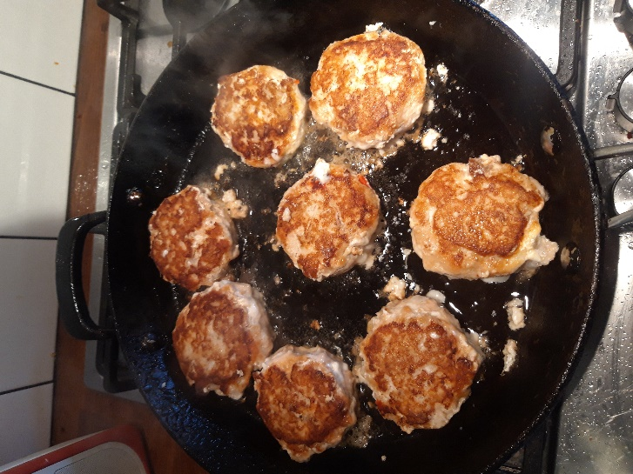
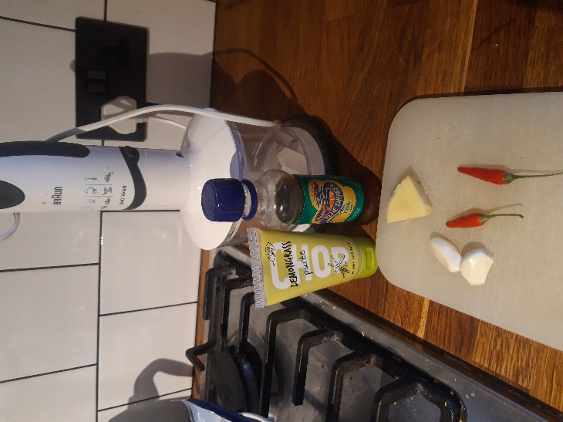

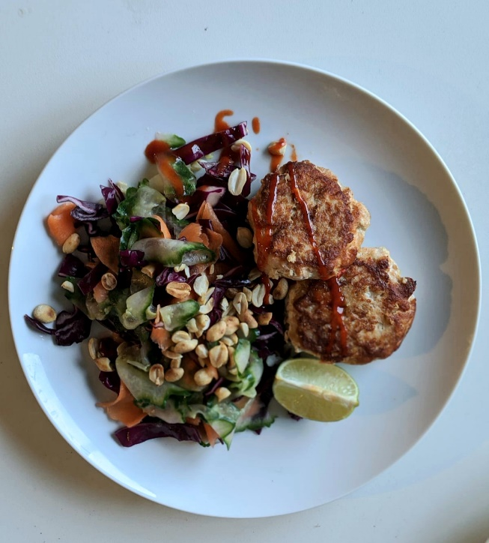

Serves 4
- 4 fillets white fish (defrosted if frozen)
- 2 fillets salmon (defrosted if frozen)
- 2 cloves garlic, crushed
- 1 thumb sized piece of ginger, finely chopped
- ½ tbsp lemongrass puree
- 1 tbsp Thai fish sauce
- 2 birds-eye chillies or 1 red chilli or 1 tsp chilli flakes
- 1 tbsp soy sauce
- 2 tbsp vegetable or sunflower oil

To serve (optional)
1 lime- cut into wedges
A large handful of peanuts- toasted briefly in a small pan and roughly chopped
Sweet chilli sauce

You will need a food processer, a bowl, a chopping board, a large frying pan, a spatula

- In your food processer grind the garlic, chillies and ginger until they resemble a paste.
- Add the lemongrass, fish sauce, soy sauce and blend again.
- Chop the fish into small chunks and add to the blender. If you run out of space in your blender you can do this in two batches and combine everything in a bowl. Make sure the fish and the aromatics are well mixed.
- Using your hands, form the mixture into eight small patties. Put them on a plate and chill in the fridge for half an hour.
- Heat the oil in a large saucepan. Cook the fishcakes for about 5 minutes on each side until firm, crisp and golden. (Cut one fishcake in half to check if you’re not sure)
- Serve with lime, peanuts and Asian slaw below if you like.

You might also like to make an Asian style slaw to go with your fishcakes…
Asian slaw
- ½ a red cabbage, shredded
- 2 carrots peeled and grated
- ½ a cucumber thinly sliced (using a potato peeler works well)
- 1 tsp lime juice (from ½ a lime)
- 1 tsp soy sauce
- ½ tsp sesame oil
- Handful of fresh coriander (optional)
- Sesame seeds (optional)

- Simply shred and slice your vegetables. Chop your herbs if using.
- Mix the lime juice, soy sauce and sesame oil, drizzle over your salad and mix well. Top with sesame seeds if using.

