Botanic Cottage Community Cook Club 10th June 2020

Chocolate and coconut macaroons
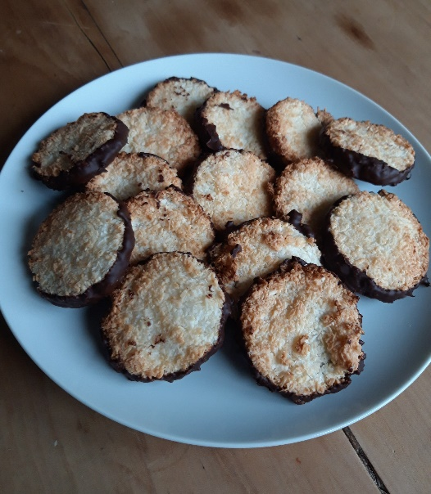

Ingredients
- 150g desiccated coconut
- 2 eggs
- 100g caster sugar
- 100g chocolate- milk or dark

You will need a mixing bowl, a spoon, a small scone cutter (I used 4cm), a baking tray lined with baking paper, a small glass bowl and a pot.

Makes about 16
Method
1. Preheat your oven to 180 degrees/ gas mark 4.
2. Separate your eggs. The easiest way is to crack the egg over a large bowl and gently pour the egg yolk from one side of the shell to the other.
3. Put the egg yolks in a separate bowl of tub and cover and put in the fridge (see note below for ideas on how to use them)
4. Add the sugar and coconut to the bowl and mix well.
5. Pour mixture on to a clean work surface and flatten with your hands. You want the dough to be about 1cm thick.
6. Use a small cutter or glass and cut rounds from the mixture. Gently place on to the baking tray. The dough is soft so don’t worry if it takes a few tries.
7. Bake in the oven for 12-15 minutes until golden around the edges. Allow to cool on the tray.
8. When cool, melt your chocolate. The safest way to do this (burnt chocolate is horrible) is to place the chocolate in a small glass bowl over a small pot with an inch of water in it. The bowl shouldn’t be touching the water, the steam will do the work. Bring the water to a simmer and stir as the chocolate gently melts.
9. Dip your coconut macaroons into the chocolate, you can dip half, or do the same as me and coat the bottoms. Place back on the baking paper until the chocolate is set.

Love your leftovers
Make sure to use your egg yolks within a day or two. You can add them to scrambled eggs or an omelette for a richer breakfast favourite. You could also use them in a quiche or to make custard or mayonnaise.

