Botanic Cottage Community Cook Club 25th June 2020

Chocolate brownies

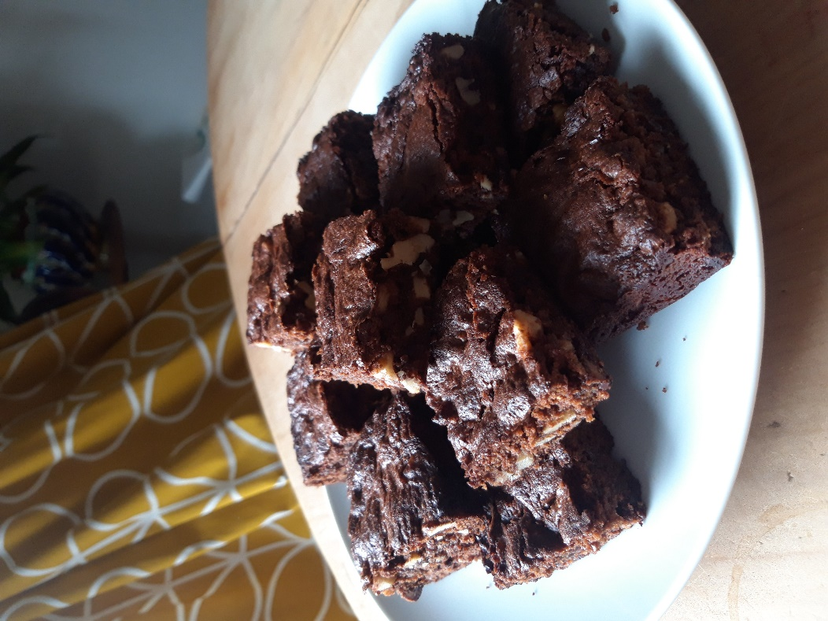

Ingredients
- 100g butter
- 200g chocolate- plain or milk
- 150g soft brown sugar (dark or light both good)
- 50g self-raising flour (or plain plus 1 tsp baking powder)
- 2 eggs
- 100g walnuts or pecans
- 1 tsp vanilla essence (optional)

You will need a small pan, a chopping board, a mixing bowl and a small baking tin lined with baking paper (mine is 24x 24cm)

Makes 16

Method
1. Preheat the oven to 180 degrees.
2. In a small pan gently melt 100g butter with 100g chocolate. (Keep an eye on it as it won’t take long). Turn off the heat.
3. In a mixing bowl measure out 150g sugar and 50g self-raising flour. Add 1 tsp vanilla essence if using.
4. Add both eggs to the mixing bowl. Lightly beat the eggs.
5. On a chopping board roughly chop the remaining 100g chocolate and the nuts.
6. Add the melted chocolate and butter to the mixing bowl and mix until combined.
7. Add the walnuts and chopped chocolate to the mixing bowl.
8. Pour the mixture into your baking tin and bake for around 25 minutes. There will still be a bit of a squidge in the mixture- this is a good thing!
9. Allow to cool in the tin before carefully transferring to a chopping board and cutting into 16 pieces.

