Botanic Cottage Community Cook Club 10th June 2020

Gazpacho soup
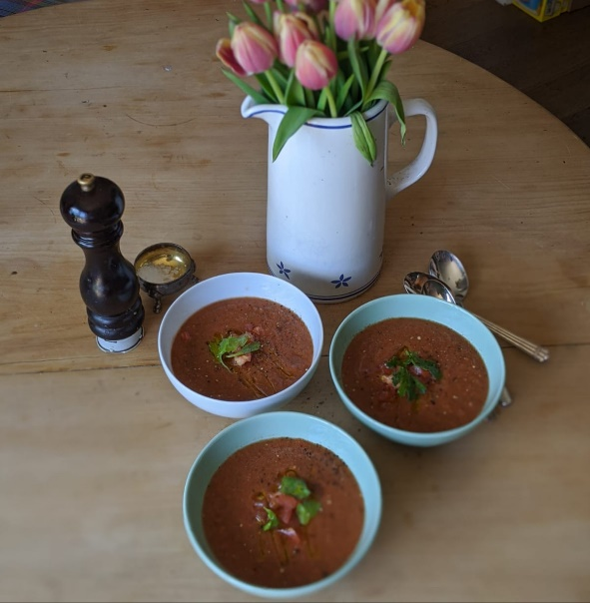

Ingredients
- 5 tomatoes
- 1/2 cucumber
- 1 red pepper
- 3 spring onions, trimmed
- 2 cloves garlic
- 1 tablespoon wine vinegar
- 1 tablespoon tomato puree
- 3 stalks celery
- Salt and pepper to taste

To serve - A few celery leaves or some fresh parsley (optional) and a little extra virgin olive oil.
You will need a chopping board, a knife and a jug or pan that will fit in your fridge.

Serves 4
Method
1. Chop all the vegetables roughly, reserving half a tomato for later.
2. Using a blender, whizz all of the ingredients in batches with a little water, adding to the pot or jug as you go.
3. Mix well, adding a little extra water if you like.
4. Cool in the fridge until ready to serve.
5. Dice the remaining half a tomato.
6. Pour into bowls and garnish with some chopped tomato, chopped herbs if using and a little drizzle of extra virgin olive oil.

