Botanic Cottage Community Cook Club 10th June 2020

Granola bars
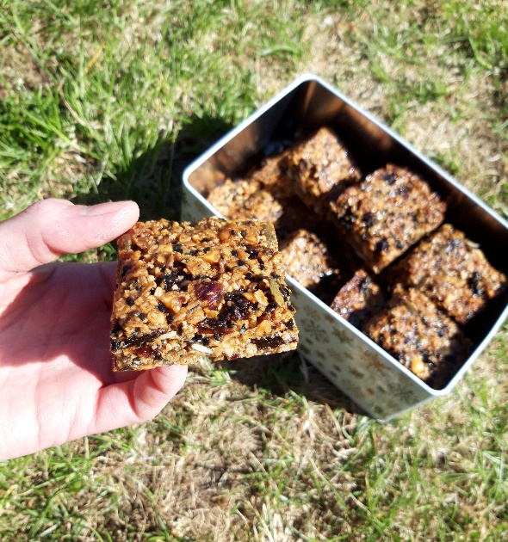

Ingredients
- 100g butter
- 200g porridge oats
- 200g mixed nuts and seeds- try walnuts, hazelnuts, almonds, sesame seeds, sunflower seeds, pumpkin seeds, linseed,
- 100g dried fruit- raisins, sultanas, chopped dried apricots, prunes or dates
- 3 tablespoons golden syrup or honey
- 100g light muscovado sugar
- 1 tsp ground cinnamon
You will need a baking tray, a mixing bowl, a small saucepan, a wooden spoon and a small deep casserole dish or tin lined with baking paper (approx. 20x20cm but use what you have)
Makes 16
Method
1. Preheat the oven to 160 degrees. Line your deep tin with baking paper.
2. Measure out the oats, nuts and seeds and spread them out on a baking tray. Roughly chop any larger nuts. Toast in the oven for ten minutes.
3. In a mixing bowl measure out the dried fruit. Roughly chop any larger dried fruits (like apricots or prunes).
4. Into a small saucepan measure out the sugar, golden syrup or honey and butter. Gently melt over a low heat.
5. Carefully remove the toasted oat mixture from the oven.
6. Add 1 tsp ground cinnamon to the oats.
7. Mix together the oat mixture, dried fruit and melted butter and sugar in the mixing bowl.
8. Press the mixture into the lined baking tin and smooth down.
9. Bake for 30 minutes until golden brown. The mixture will look liquid when you remove it from the oven- don’t worry!
10. Cool in the tin for ten minutes then using the tip of a knife, mark into 16 squares. Leave in the tin to cool completely before removing and enjoying!
