Botanic Cottage Community Cook Club 25th June 2020
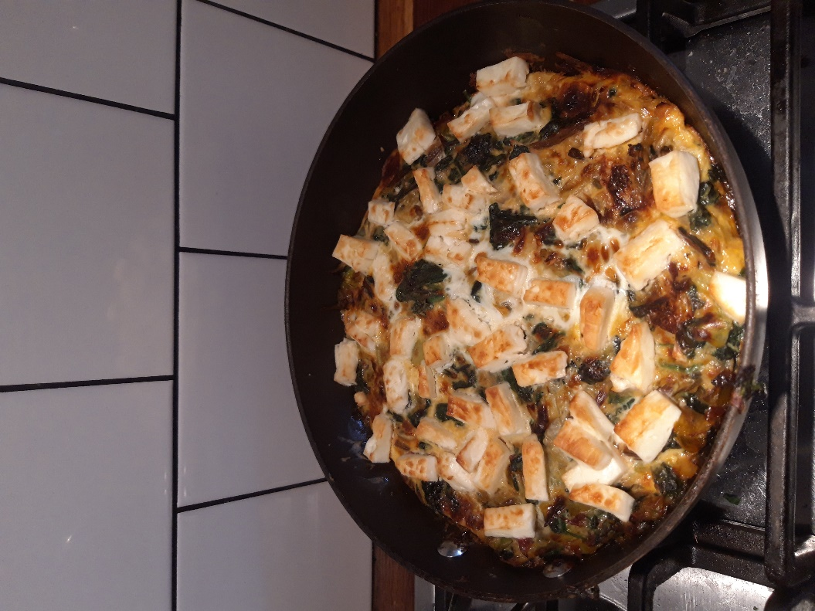
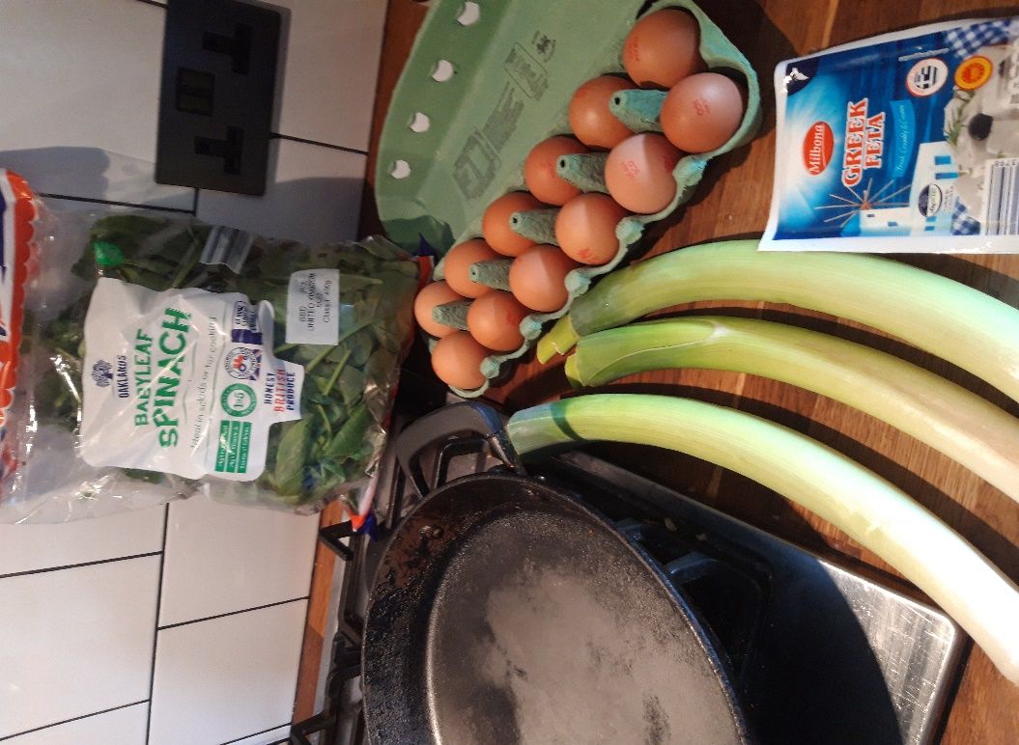
Leek, card and feta frittata

Ingredients
- 1 tablespoon olive oil
- 3 leeks
- 2 handfuls chard (or spinach)
- 4 eggs, beaten
- 100g feta cheese
- Salt and pepper

Serves 4

You will need- a medium frying pan- ideally with a metal handle, a chopping board and a knife.

Method
1. First wash your leeks. I split mine down the middle and run under the tap to remove any grit. Chop into roughly 2cm ‘coins’.
2. Heat a tablespoon of oil in your frying pan over a medium heat. Add the leeks.
3. Add a pinch of salt and pepper and cook until the leeks are soft and reduced in size (around ten minutes).
4. Wash and roughly chop your green leaves. Add to the pan and cook until the leaves have wilted and their liquid has evaporated.
5. Add the eggs to the pan, move a little to make sure that the vegetables and eggs are evenly spread around the pan. Turn the heat down.
6. Cook on a low heat for around five minutes until the eggs look partially set.
7. Dice the feta cheese.
8. Preheat the grill on your oven.
9. Scatter the feta over the top of the frittata.
10. Transfer to the grill and cook until the eggs are fully cooked and the cheese is golden. Be careful the handle will get hot.
11. Cut into generous slices and serve with salad.

