Botanic Cottage Community Cook Club 25th June 2020

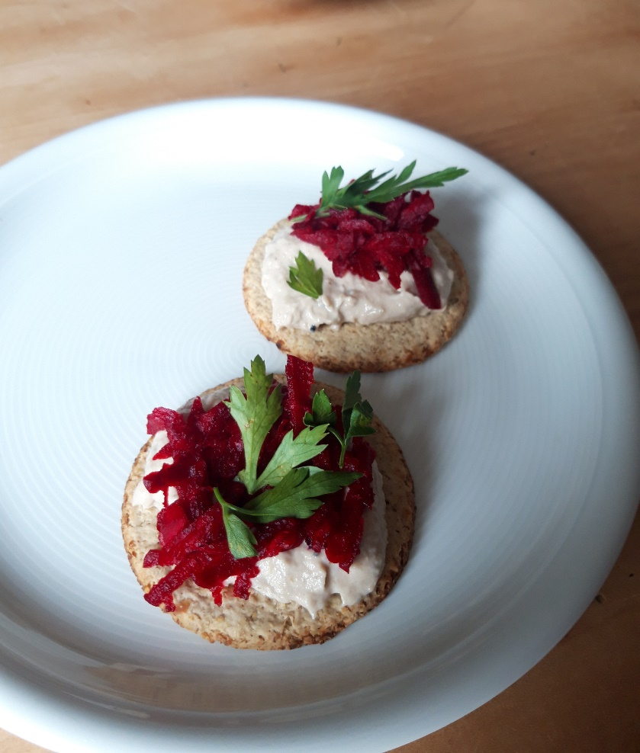
Smoked mackerel pâté

Ingredients
- 200g pre-cooked smoked mackerel fillets
- 2 tablespoons mayonnaise
- Half a lemon
- 1 tsp horseradish sauce (optional)
- A sprig of parsley (optional)
- 2 raw beetroots

To serve- oatcakes or toast.

You will need - a small blender, a grater, a chopping board and a knife.

Method
1. Remove the skin from the fish fillets and any obvious large bones.
2. Break the fillets into large chunks and place in the blender with the mayonnaise, horseradish if using and juice of half a lemon.
3. Blend briefly for a rough pâté or longer for smooth.
4. Using a clean teaspoon carefully taste the pâté. You can add more mayonnaise, lemon or horseradish to taste.
5. Transfer to a bowl and garnish with parsley if using.
6. Peel the beetroot and then grate. Use gloves if you’re worried about pink hands! (You can use the discarded lemon half to help clean your hands after).
7. Serve the pâté with beetroot and oatcakes.

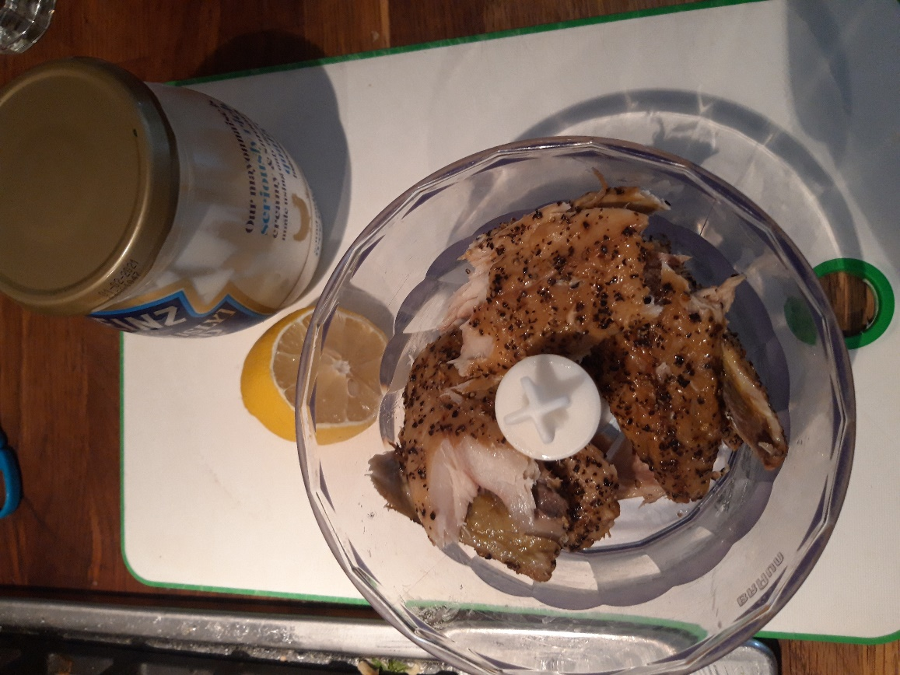

It’s easiest to make the pâté in a food processor, though can be done without using a fork or wooden spoon to mix together.

