Botanic Cottage Community Cook Club 10th June 2020

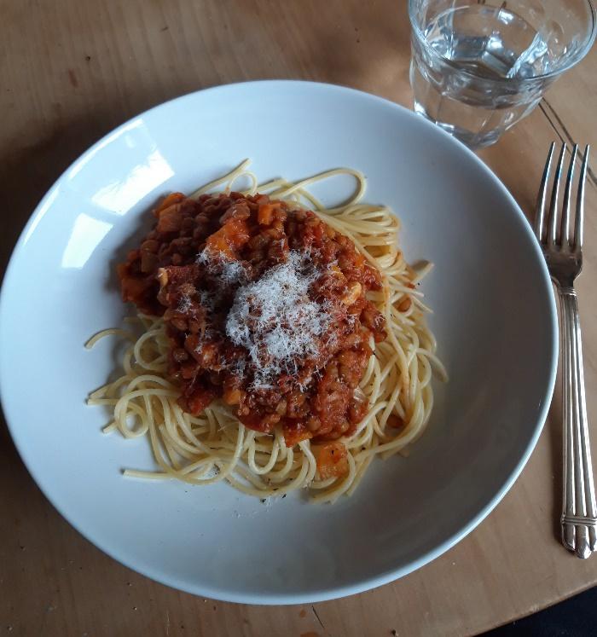
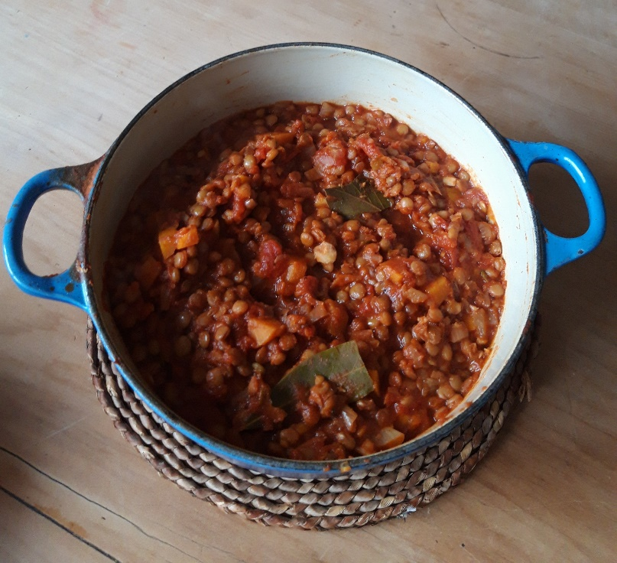
Spaghetti bolognaise

Ingredients

- 1 tablespoon olive oil
- 1 large onion, diced
- 400g lean beef mince OR 400g green lentils
- 2/3 carrots, peeled and diced
- 2 stalks celery, trimmed and diced
- 2 cloves garlic, peeled and finely chopped
- 2 tins chopped tomatoes
- 2 tsp dried chopped herbs – oregano, basil or rosemary OR a sprig of fresh herbs
- 2 bay leaves
- 2 tbsp tomato puree
- 1 tsp soy sauce
- Salt and pepper
- 400g dried spaghetti
- Parmesan cheese to serve (optional)

You will need a chopping board, a sharp knife, two pots, a colander.

Serves 4
Method
1. Peel and chop the onions, garlic, celery and carrots.
2. Heat a tablespoon of olive oil over a medium heat. Add the diced vegetables and a small pinch of salt. Cook gently for around ten minutes until the onions are soft.
3. If using fresh herbs – finely chop and add to the pan, or add the dried herbs.
4. Meat- turn the heat up and add the beef mince, move around the pan to brown and break up the mince.
Vegetarian- add the cooked lentils (see recipe introduction) or Quorn mince.
5. Add the tomato puree and cook for one minute
6. Add the chopped tomatoes, bay leaves and some black pepper.
7. Simmer gently for around twenty minutes.
8. Put a large pan of water on to boil. Add a pinch of salt and then the spaghetti. Cook according to packet instructions, usually around 9 minutes.
9. Taste the sauce and add more salt and pepper if required.
10. Serve the pasta with a generous helping of bolognaise sauce and some parmesan cheese if you like.

Love your leftovers
Leftovers will keep in the fridge for a day or two but I recommend freezing some for an easy meal another night. To take your leftovers in a new direction, add a tin of kidney beans and some dried chilli and ground coriander, simmer together to make a delicious chilli con carne/ chilli ‘non’ carne and enjoy with rice, tortilla wraps or as a baked potato filling.

