Botanic Cottage Community Cook Club 9th July 2020

Coconut, courgette and spinach dahl

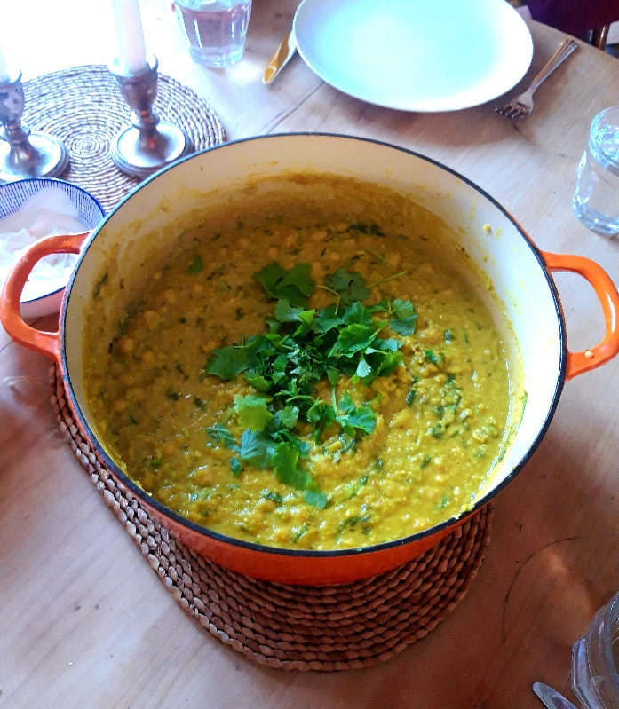

Ingredients
- 1 tbsp oil
- 2 onions, diced
- 3 cloves garlic, peeled and finely chopped
- 1 inch piece of ginger, grated or finely chopped
- 1 tsp ground coriander
- 1 tsp ground cumin
- ½ tsp chilli flakes (optional)
- 1 tsp ground turmeric
- 1 large or 2 small courgettes
- 200g red lentils, rinsed
- 1 tin coconut milk
- 600ml veg stock or water.
- 1 tin chickpeas (or 300g home-cooked)
- Large handful spinach, chopped if leaves are large.
- Bunch of fresh coriander, roughly chopped.
- Half a lemon.

You will need a saucepan, a chopping board and knife, a wooden spoon.

Serves 4.

Method
- 1. Start by heating your oil in a large saucepan. Add the onions and cook for around 5 minutes until starting to soften.
- Add the garlic, ginger, cumin, coriander, turmeric and chilli flakes (if using). Cook stirring frequently for a few minutes until the mixture smells spicy and aromatic.
- Grate the courgette into the pan.
- Add the lentils to the pan along with the coconut milk and the stock or water.
- Simmer everything together for around half an hour, stirring regularly to prevent lentils sticking to the bottom of the pot. Lentils cook differently depending on their age and size- but should be very soft and starting to collapse.
- Add the chickpeas and cook for a further five minutes. Check the seasoning adding salt if required.
- Add the spinach and half of the coriander to the pan and cook very briefly until the leaves wilt.
- Finish with a squeeze of lemon and the rest of the chopped coriander.

Love your leftovers- this recipe will freeze well for another night. Alternatively add more stock and blitz to make a warming spicy lentil soup.

