Botanic Cottage Community Cook Club 9th July 2020

Fairy cakes
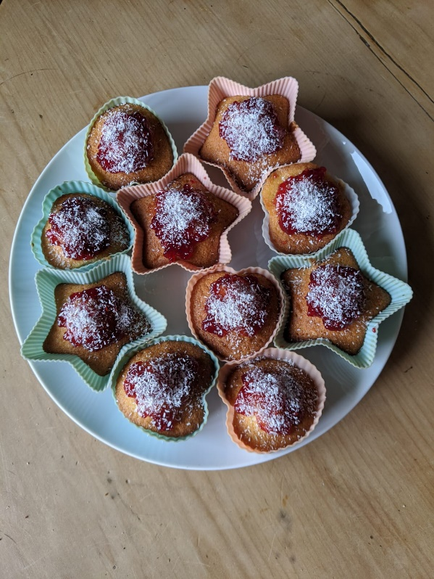

Ingredients
- 110g soft butter
- 110g self-raising flour
- 110g caster sugar
- 2 eggs, lightly beaten
- 2 tbsp milk
- ½ tsp vanilla extract

Topping
- 6 tsp raspberry jam
- Dessicated coconut
- OR icing sugar and small sweets.

Makes 12.

You will need- a mixing bowl, a wooden spoon, scales, a 12 cup baking tray and paper cases (or reusable silicone cake cakes).
Method

1. Preheat your oven to 180 degrees. Line a tin with paper cake cases.
2. Measure your butter and sugar into a mixing bowl and beat with a wooden spoon until smooth and creamy.
3. Add the eggs and beat to combine.
4. Add the vanilla extract, flour and milk and mix again.
5. Divide the mixture between the cake cases.
6. Bake for about 15 minutes until risen. The tops should spring back when gently touched.
Allow to cool.
7. When cool, top each cake with half a teaspoon of jam and a scattering of desiccated coconut. Alternatively use icing sugar (follow packet instructions) and decorate as you like.
8. Stored in an airtight container they’ll keep for about 3-4 days, but can also be frozen (un-iced).

