Botanic Cottage Community Cook Club 24th July 2020

Fish finger wrap
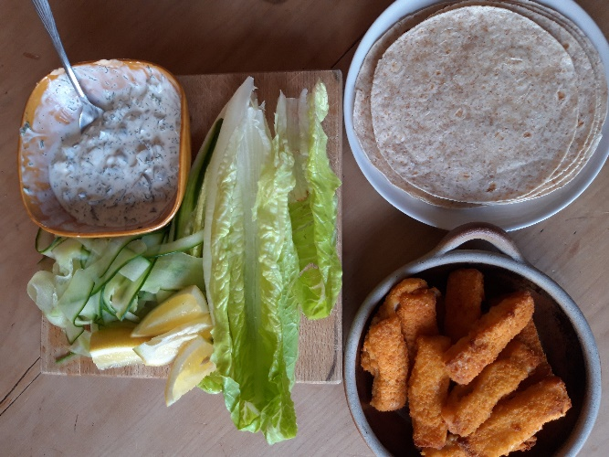

Ingredients (per person)

- Fish fingers- 4 per person
- Small wheat wraps- 2 per person
- Salad leaves
- ½ a cucumber
- 1 lemon

For the remoulade
- 1 tsp dill
- 2 large/4 small gherkins
- Heaped tbsp capers
- 2-3 tbsp mayonnaise

Method

1. Cook the fish fingers according to the instructions on the packet, it’s usually around 15 minutes in the oven.
2. On a chopping board roughly chop the gherkins, capers and dill together.
3. Transfer to a bowl and add the mayonnaise and a squeeze of lemon.
4. Taste and add salt and pepper if needed, or more lemon. You can also add a little of the vinegar from the caper jar for more of a kick.
5. Wash and chop the lettuce and cucumber. I cut my cucumber into ribbons using a peeler which looks fun, but sliced is equally good.
6. Chop the lemon into wedges.
7. Heat the wraps (for 8 wraps I give them 1 minute in the microwave or a few minutes in the oven).
8. To assemble - fill each wrap with a spoonful of the remoulade, 2 fish fingers, some crunchy salad and a squeeze of lemon. Roll up the wrap and enjoy. Napkins recommended!

