Botanic Cottage Community Cook Club 24th July 2020

Green omelette
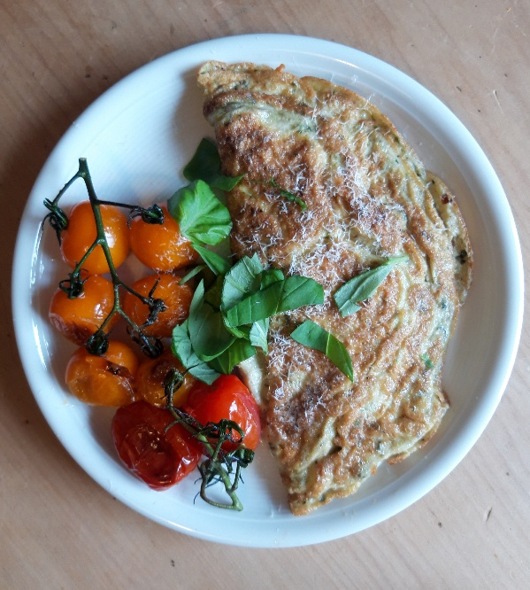

Ingredients (per person)

- Handful cherry tomatoes
- ½ tsp butter and 1½ tsp oil
- 2 eggs
- 1 tbsp pesto- homemade or shop-bought
- A little grated cheese
- Salt and pepper

To garnish- basil leaves and parmesan (optional).

You will need- a small saucepan, a spatula, a bowl.

Method

1. Heat the pan over a medium heat and add 1 tsp oil. Add the tomatoes and cook for a few minutes on each side. Remove from the pan and keep warm.
2. Whisk the eggs with a pinch of salt and pepper. Stir in the pesto.
3. Add ½ tsp oil and ½ tsp butter to the pan.
4. When the pan is hot add the eggs. Leave for a moment and then use a spatula to pull the edges in a little, allowing the uncooked egg to flow back into the pan. When the eggs are nearly cooked add a little cheese (if using) and then fold in half. Cook for half a minute more and then turn out onto a plate.
5. Garnish with basil and parmesan if using, and serve with the warm cherry tomatoes.

