Botanic Cottage Community Cook Club 9th July 2020

Muesli

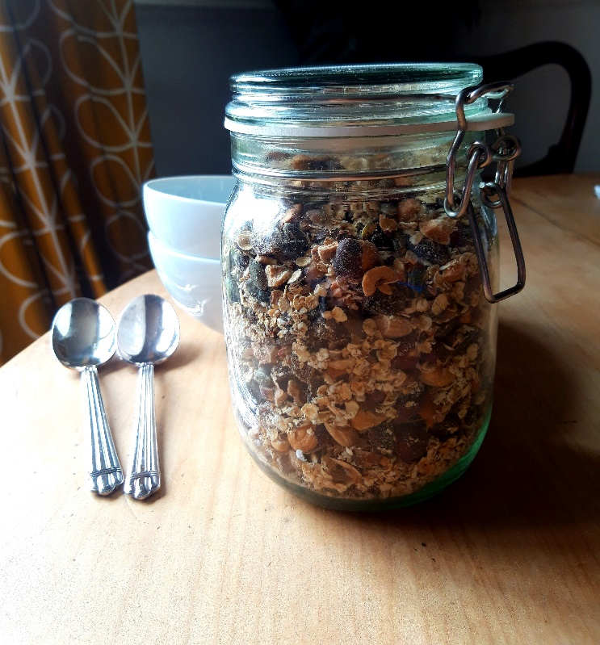

Ingredients
- 200g rolled oats
- 200g nuts- try almonds/ cashews/ walnuts/ hazelnuts...
- 100g seeds - try pumpkin/ linseed/ sunflower
- 150g dried fruit- try raisins/ apricots/ dates/ prunes
- ½- 1 tbsp sugar (optional)

Makes 650g.

You will need a large deep baking tray and spatula, a small food processor or a chopping board and knife.

Method
1. Preheat the oven to 180 degrees.
2. In a food processor briefly blitz the nuts, keeping some of them whole if you like.
3. Place the oats, nuts and seeds in the baking tray and mix to combine.
4. Toast for 20 minutes in the oven, giving them a good shake half way through.
5. Meanwhile chop any larger dried fruit (in a food processor or with a knife or scissors). I aim for all my pieces to be roughly the size of a raisin but it’s up to you.
6. Remove the tray from the oven and allow the oats, nuts and seeds to cool in the tray.
7. Add the dried fruit and sugar if using.
8. When completely cool, store in an airtight container.
9. Enjoy with milk or yogurt.

