Botanic Cottage Community Cook Club 9th July 2020

Pea and pesto soup

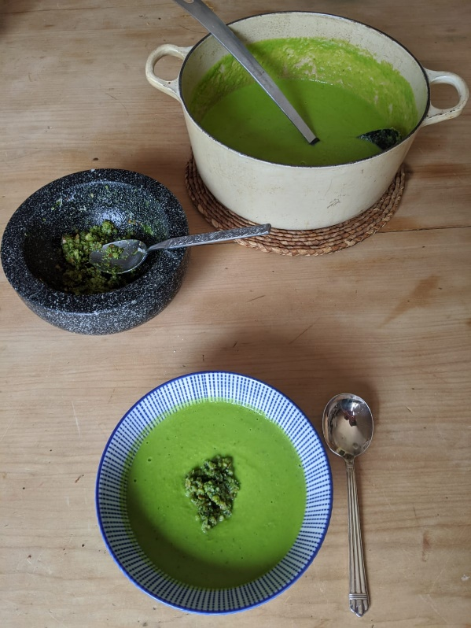

Ingredients
- 1 tbsp olive oil
- 1 onion, diced
- 2 cloves garlic, peeled and roughly chopped
- 700g frozen peas
- 600ml vegetable stock
- ½ a bunch of fresh basil
- A wedge of lemon (optional)

For the pesto
- 30g almonds or pine nuts
- 1 clove of garlic
- 1 tbsp olive oil
- 1 tbsp grated parmesan
- ½ bunch basil.

You will need - a large pot and a wooden spoon, a stick blender, a pestle and mortar or small food processor.

Method
Soup
1. Heat the oil in a large saucepan and add the onion and garlic.
2. Cook gently for 5 minutes until both are softening.
3. Add the peas and the stock, and bring to a simmer.
4. Separate the stalks and leaves of the basil, add the stalks to the pan.
5. Simmer without a lid for around ten minutes until the peas are cooked.
6. Add the basil leaves and blitz until smooth.
7. Taste and season with salt and pepper and a squeeze of lemon.

Pesto
1. In a pestle and mortar crush the garlic, nuts and basil.
2. Add the olive oil and parmesan, stir and season to taste.

If you don’t have a pestle and mortar you can either use a small food processor (but try to keep the pesto chunky), or alternatively chop everything on a large chopping board.

