Botanic Cottage Community Cook Club 24th July 2020

Roasted vegetable quiche

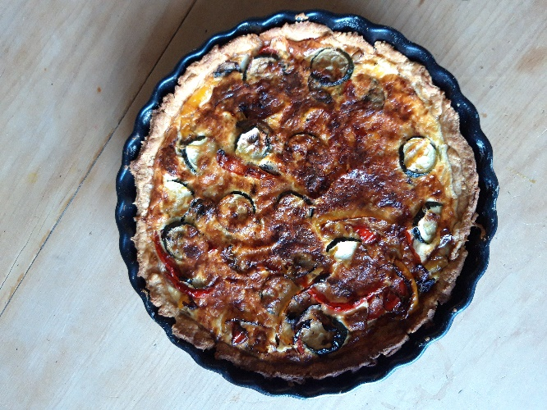
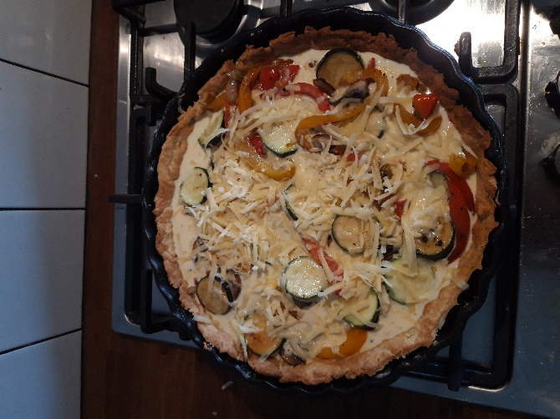

Ingredients

For the pastry
- 200g plain flour
- 100g cold butter
- Pinch salt
- 2-4 tbsp water.

Measure the flour into a large bowl then add the cold butter either in small cubes or grate it (my preferred method, it’s so quick!) and a pinch of salt. Using your fingertips, rub in the butter until it resembles breadcrumbs. Carefully add cold water a spoonful at a time and mix well until the dough comes together. Roll into a ball, wrap in clingfilm or baking paper and cool in the fridge for at least half an hour before using.

For the quiche
- 300g shortcrust pastry (from pastry recipe or shop-bought)
- 2 tbsp olive oil
- 1 onion, diced
- 2 cloves garlic, finely chopped
- 2 peppers
- 1 courgette
- Small handful mushrooms
- 1 tsp dried or fresh herbs (eg. rosemary, oregano, parsley)
- 100ml milk
- 100ml creme fraiche (or substitute cream or milk)
- 100g cheddar cheese, grated
- 4 eggs
- Salt and pepper

You will need a quiche dish (approx 20cm), a measuring jug, a rolling pin, a frying pan, a chopping board and a knife.

Serves 4-6

Method

1. Preheat the oven to 200 degrees. Roll out the pastry and carefully lift it into your quiche dish. Don’t worry if it’s imperfect, you can patch the pastry easily at this point.
2. Using a fork prick the base all over. Trim the edges of the pastry.
3. Bake the pastry case for 15-20 minutes until golden and starting to shrink from the edges. Check halfway through that no bubbles are forming, give them a prod with your fork if there are.
4. While the pastry is cooking, dice your onion and chop the garlic finely.
5. Heat a frying pan with the olive oil and gently cook the onion and garlic until starting to soften. Add a pinch of salt and some black pepper.
6. Slice the pepper into long strips and chop the courgette and mushrooms too. Add them to the frying pan. Cook for around 15 minutes stirring often until the vegetables are tender. Add fresh or dried herbs if using.
7. In a jug measure out the milk and creme fraiche or cream. Add the eggs and half of the cheese. Mix well.
8. When the pastry case is golden, carefully remove from the oven. Arrange the vegetables over the base. Pour over the milk, egg and cheese mixture ensuring that the pasty case is evenly filled. Top with the rest of the grated cheese.
9. Return to the oven and cook for around 30 minutes until risen, golden and smelling delicious!

