Botanic Cottage Community Cook Club 24th July 2020

Chocolate mousse

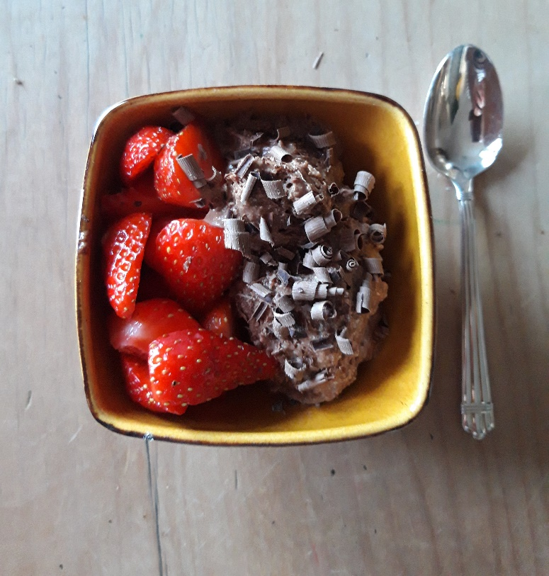

Ingredients

- 75g dark chocolate
- 2 eggs, separated
- 60g caster sugar
- 150ml double cream

To serve- strawberries, and a little extra chocolate to grate over if you like.

You will need- 2 mixing bowls (one heatproof), a whisk, a small saucepan, small serving bowls.

Serves 4.

Method

1. Break the chocolate into pieces and put in a glass bowl. Heat over a small saucepan of simmering water until melted. Take off the heat and cool a little.
2. Whisk the egg yolks and sugar in a bowl until thick and fluffy.
3. Stir the chocolate into the egg yolk mixture.
4. Whip the cream in a large bowl until it forms soft peaks.
5. Fold the cream into the chocolate mixture.
6. Whisk the egg whites until they are stiff and forming peaks.
7. Gently fold the egg whites into the chocolate mixture.
8. Divide the mixture between four small dishes or one large one and chill in the fridge.
9. Serve with a big bowl of strawberries.

