Botanic Cottage Community Cook Club 30th August 2020
Coconut fish curry

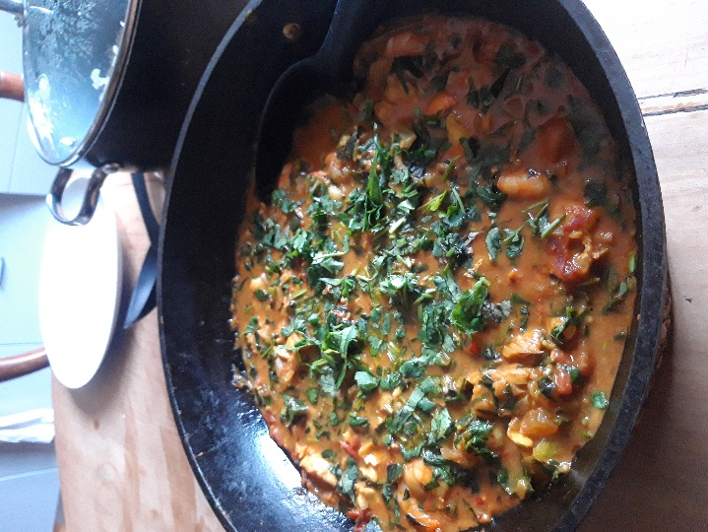

Ingredients per person
1 tbsp oil
1 onion, diced
3 cloves garlic, peeled and finely chopped
A thumb sized piece of ginger, finely chopped
1 red or green chilli, finely chopped
1 tsp each of cumin, coriander and turmeric OR 2 tsp curry powder
4 fillets of sustainable white fish (pollack is ideal, frozen is fine)
200g cooked prawns, chilled or frozen
1 tin chopped tomatoes
1 tin coconut milk
2 handfuls leafy greens - ideally spinach or chard
1 handful fresh coriander

You will need a large pot, a chopping board and knife and a spoon or spatula.

Serves 4, with rice or naan bread.

Method
1. Heat the oil in a pan over a medium heat. Add the onion and cook for a few minutes.
2. Finely chop (or whizz) the garlic, ginger and chilli and add to the pan. Cook for a minute being careful not to burn the chilli.
3. Add the dried spices or curry powder and cook for a minute until aromatic.
4. Add the tinned tomatoes, coconut milk and a pinch of salt. Heat until simmering and then check the seasoning.
5. Wash and roughly chop the leafy greens and coriander
6. Add the frozen fish and simmer until cooked through. Add the prawns and heat through.
7. Add all the leafy greens and half the coriander. Stir to wilt.
8. Take off the heat and garnish with the rest of the coriander.

