How to make a butterfly garland
What you will need
A few sheets of paper- assorted colours
A pencil
Coloured Pens/pencils
Plain white paper for template- print if you have a printer or carefully trace from computer screen
Scissors
Glue stick
Strong thread or very thin string

What to do

- Print the butterfly template or trace from the screen on to paper. I’ve included a link to one that is simple, with no fiddly bits. I’ve included 2 sizes depending on how big you’d you’re your butterflies to be. Cut out one butterfly to make your template.
- Place your coloured paper on to a flat surface and draw carefully around your chosen template onto your coloured paper, then cut out your butterflies. You will need double the number of butterflies that you want on your final garland. You might find it easier to fold the paper in half and cut 2 layers at once.

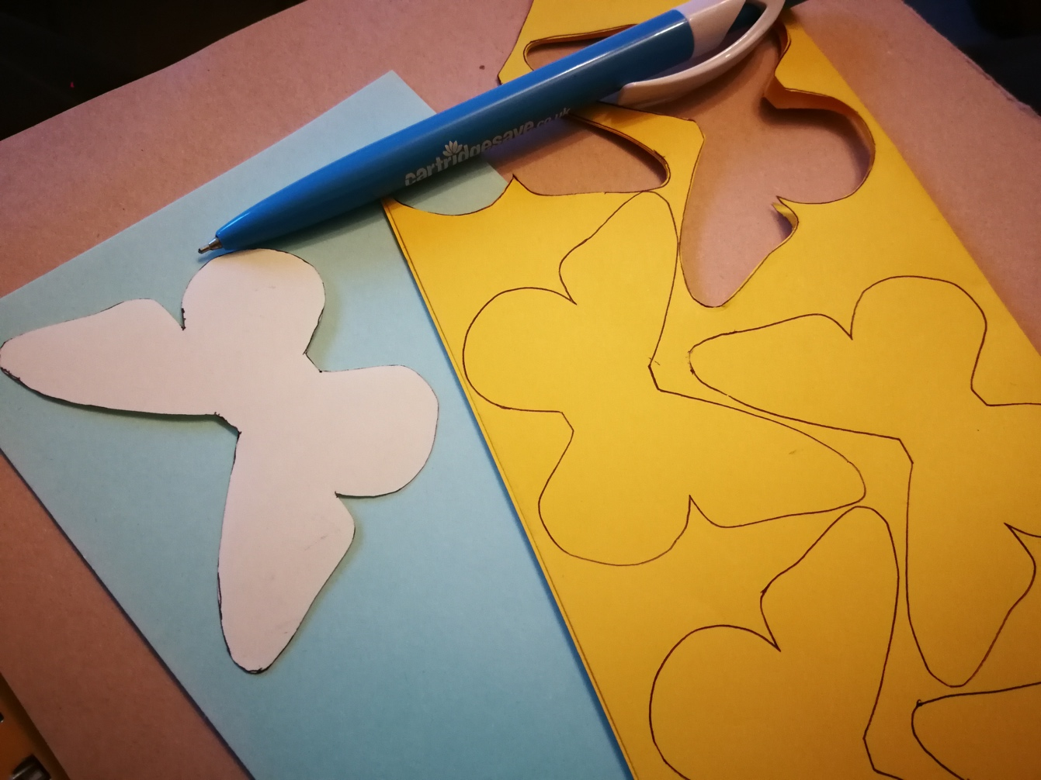
- Cut your thread to the required length (e.g. 9 butterflies, spaced approx. 10cm apart used a piece of string 120cm long) and tie a loop at each end for hanging.
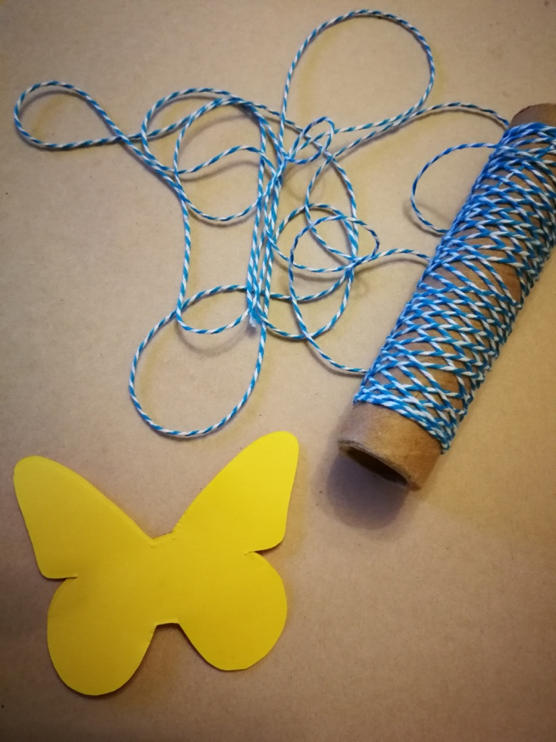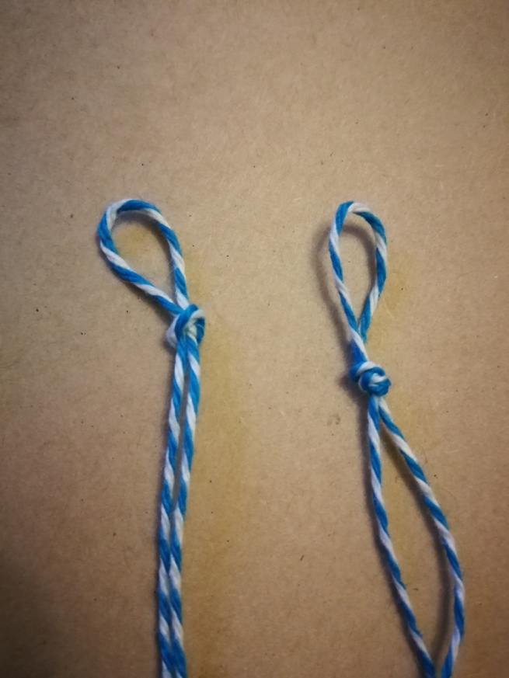

- Find the centre of your thread – this is where you will place your first butterfly. Glue on the reverse side of a butterfly (the side you don't want to see) and carefully lay the thread along the centre.
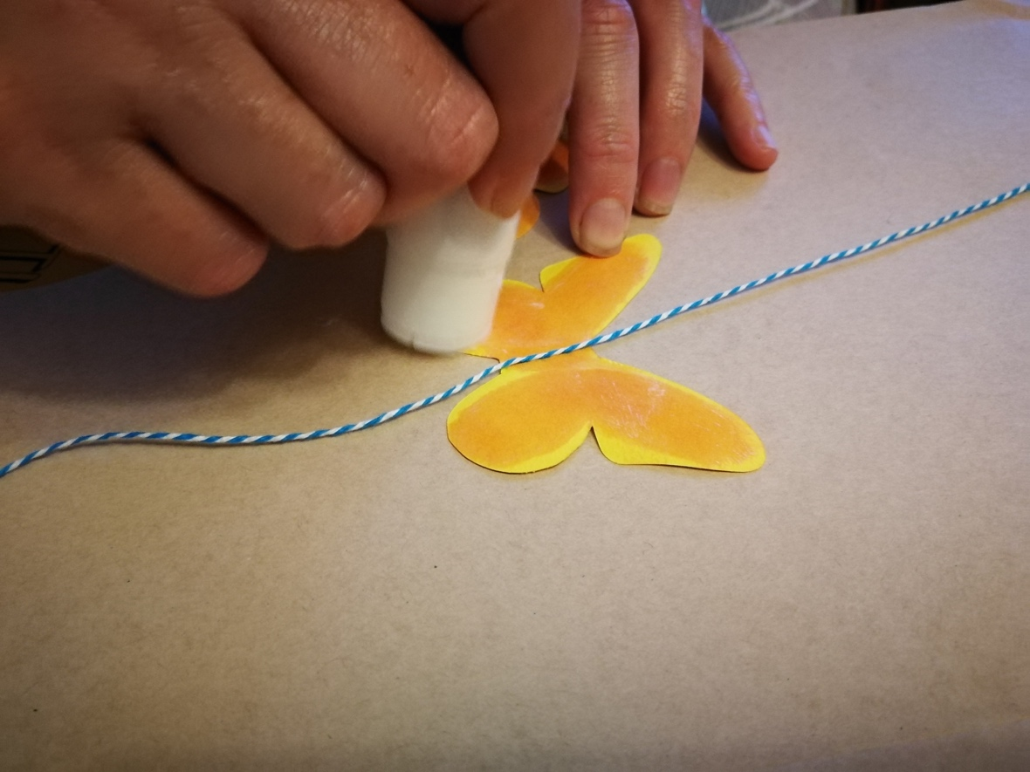
- Place a second butterfly, reverse side down, onto the glued side and press together firmly, making sure that the thread is central and the butterflies are lined up. Pinch either side of the thread to hold it in place.
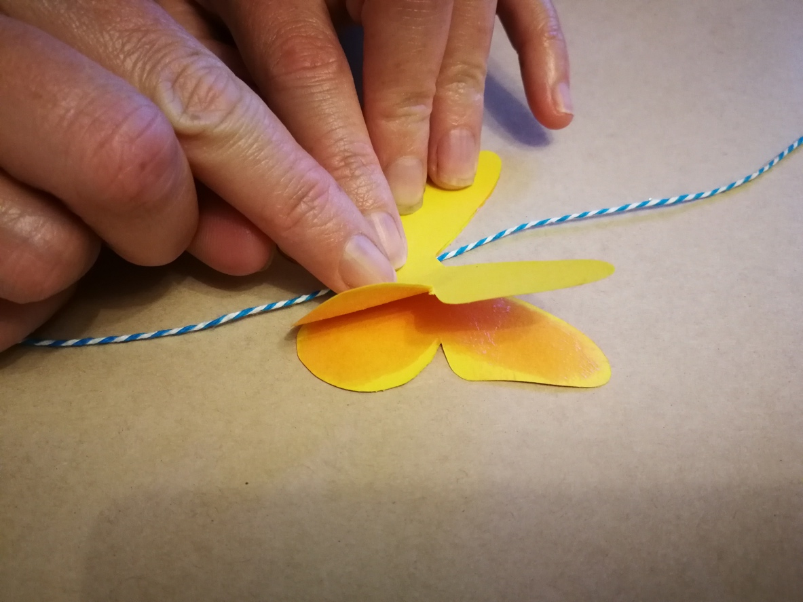
- Attach the remaining butterflies, making sure they're fairly evenly spaced along the thread (a measuring tape or ruler will help with this if you want it to be more exact).
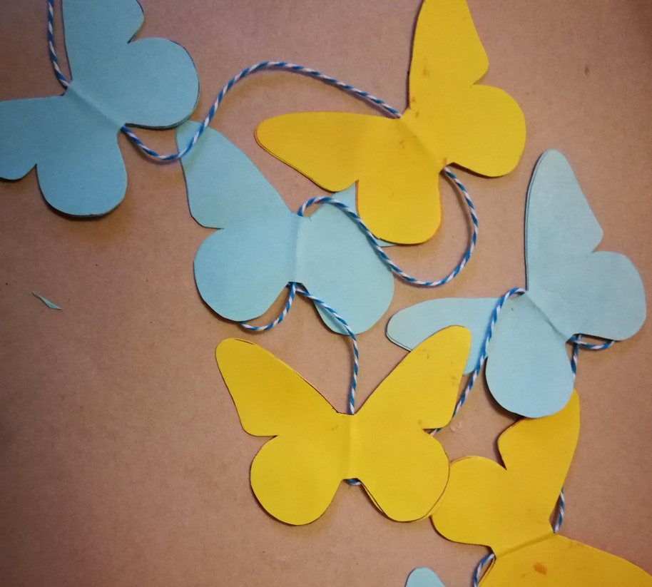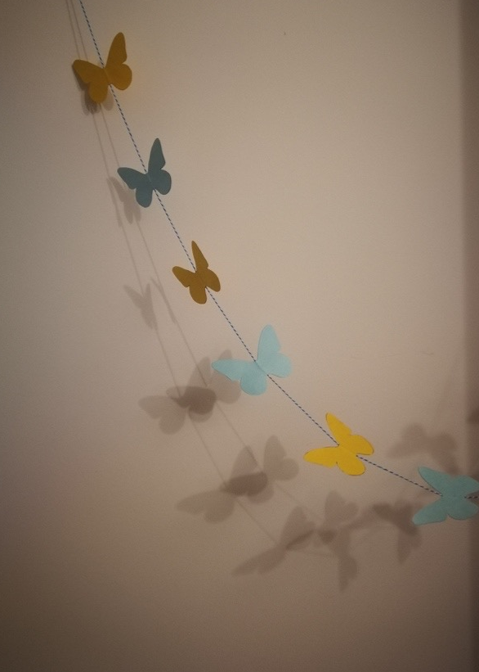
- Trim any uneven edges on your butterflies, but be careful not to cut the thread!

- Write a note of gratitude on each butterfly – “I’m grateful for ----” OR. “---- makes me smile”. Add more over time, maybe one per day/week as time passes.

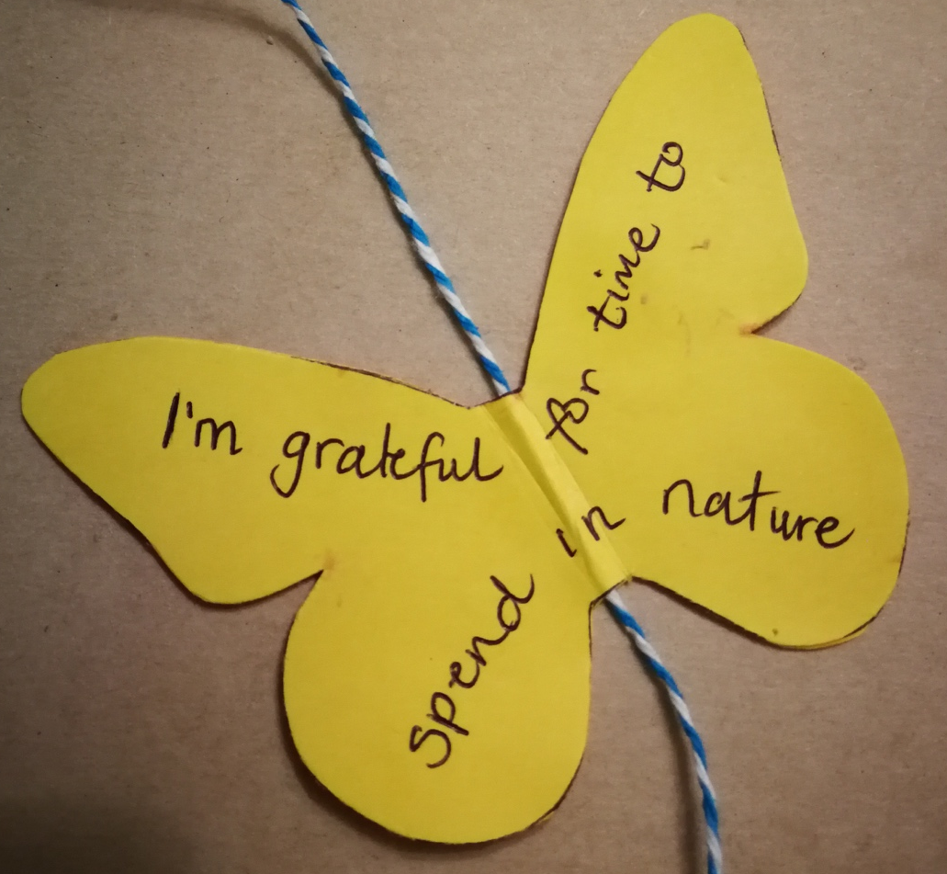

- You can also choose to decorate each butterfly. Experiment with different styles of writing, or embellish with drawing, adding colours or textures to the spaces around the writing.

- Hang your finished garland along the wall, across the ceiling or make more than one garland and cluster several together vertically to create your own ‘ kaleidoscope’ of butterflies.

