Botanic Cottage Community Cook Club 12th August 2020

Overnight breakfast cranachan

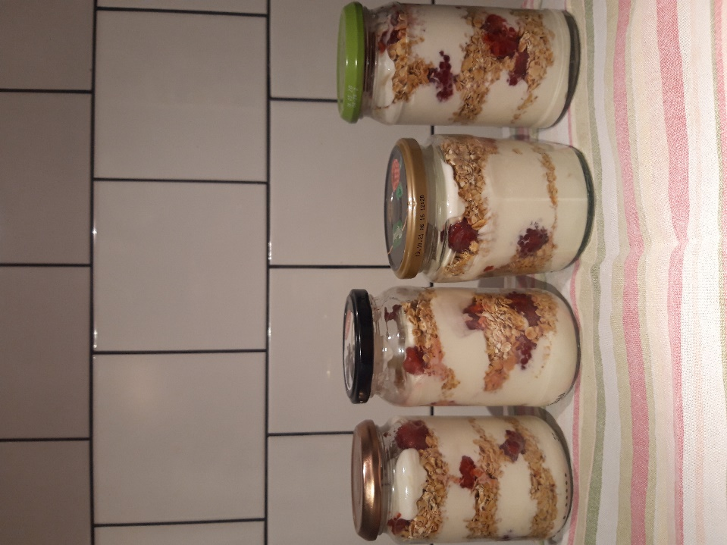

Ingredients per person
200g greek yogurt
1 tsp honey
3 tablespoons oats
75g/ a handful raspberries

You will need - a small mixing bowl, a serving bowl, glass or jar.

Method

1. In a bowl mix together the greek yogurt and honey.
2. In each serving dish add layers of yogurt, oats and raspberries finishing with raspberries on top.
3. Cover and put in the fridge until morning.

