Botanic Cottage Community Cook Club 12th August 2020

Ratatouille

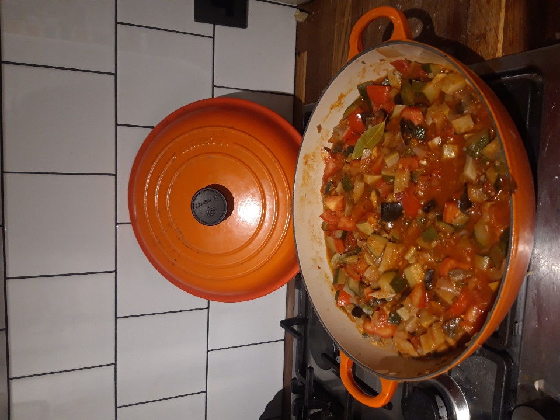

Ingredients
3 tablespoons olive oil
1 large onion, diced
4 garlic cloves, peeled and sliced
1 small aubergine, diced
3 courgettes, diced
5 tomatoes diced or 1 tin chopped tomatoes
A few sprigs of oregano, or 1tsp dried oregano
A bay leaf
Salt and pepper

You will need a large pan, a chopping board and a knife, a wooden spoon.

Serves 4 with baked potatoes or pasta.
Method

. 1. Heat the olive oil and add the diced onion. Cook gently for 5 minutes then add the garlic and herbs.
2. Add the chopped aubergine and courgettes and continue to cook slowly for about 15 minutes, with a lid on if you can.
3. Add the tomatoes and continue to cook for another ten minutes.
4. Add salt and pepper to taste.

