Botanic Cottage Community Cook Club 30th August 2020
Shakshuka

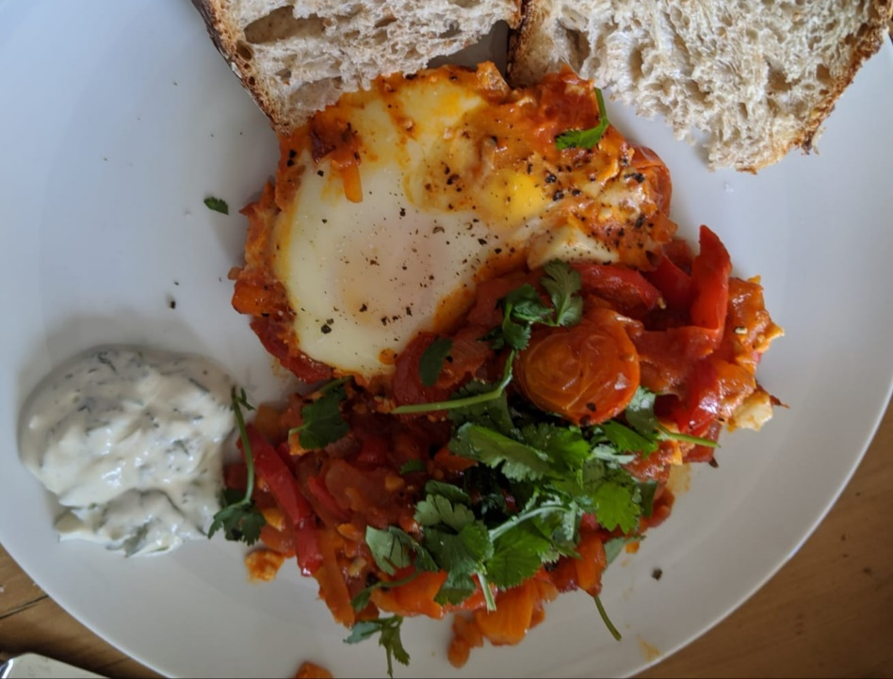

Ingredients per person
1 or 2 eggs per person
2 tbsp oil
1 large onion, sliced
4 cloves garlic, finely chopped
3 red or yellow peppers, decored and sliced
1 tsp smoked paprika
1 tsp dried coriander
1 tsp dried cumin
1 tin chopped tomatoes
4 tomatoes, diced OR an extra tin of chopped tomatoes
1 tbsp tomato puree
A handful of fresh coriander
100g feta cheese (optional)
Salt and pepper
You will need a large ovenproof frying pan OR a regular frying pan and a casserole dish, also a chopping board, a knife and a spatula or wooden spoon.

Serves 4

Method
1. In a large pan heat the oil and add the sliced onion and peppers. Cook on a low heat for ten minutes stirring regularly.
2. Add the garlic and dried spices and cook for a few minutes until the spices start to smell good.
3. Add the chopped tomatoes, tinned tomatoes, tomato puree and a pinch of salt. Simmer for at least ten minutes, longer if you have time, and then season to taste.
4. Preheat the oven to 200 degrees. If using an oven dish transfer the mixture now
5. Dice the feta (if using) and roughly chop the coriander.
6. Make indentations in the mixture and crack one or two eggs into each hole.
7. Scatter the feta over the top and transfer the pan to the oven.
8. Bake for ten minutes until the egg whites have set. They may need a little longer depending on the size and temperature of the eggs so you may need to pop it back in for a few minutes.
9. Garnish with the chopped coriander and serve at the table with hunks of bread.

.

