Botanic Cottage Community Cook Club 30th August 2020
Strawberry and cream sponge cake

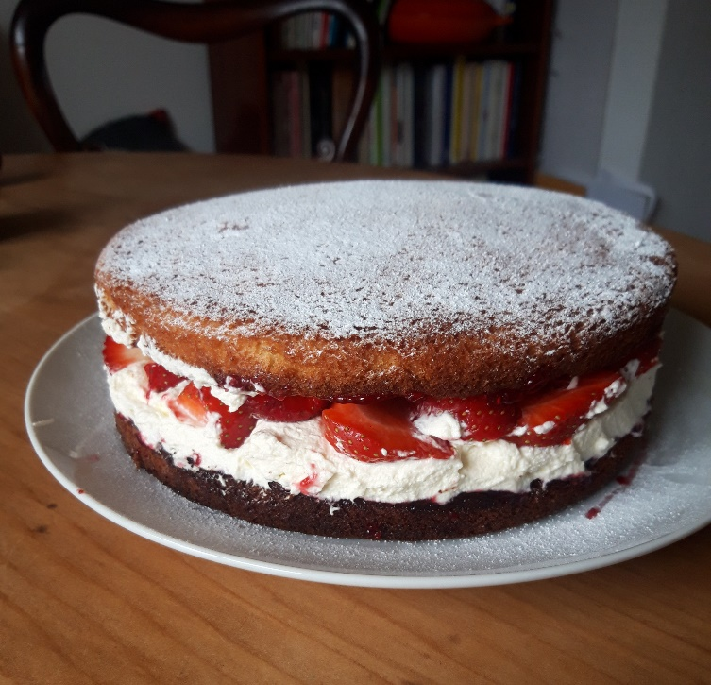

Ingredients
170g soft butter (or margarine)
170g self-raising flour
170g caster sugar
1 tsp baking powder
3 eggs
1 tsp vanilla extract

To serve
200ml double cream
1 small punnet strawberries
2 tsp icing sugar

You will need a large mixing bowl, two 20cm sandwich tins, baking paper, a whisk, scales, a wooden spoon, a sieve.

Serves 8

Method
1. Heat oven to 180°C.
2. Line your sandwich tins with baking paper and a little oil or butter.
3. Beat together the soft butter, sugar and vanilla until smooth and creamy.
4. Add the eggs one at a time and beat.
5. Add the flour and baking powder and continue to mix. The mixture should be soft and easily drop off a spoon. If it is very stiff add a tablespoon of milk or water.
Divide the mixture into your two tins.
6. Bake in the oven for around 20 minutes until golden brown. The cakes should press back slightly when touched, and a skewer should come out clean.
Leave in the tins for five minutes then turn out on to a rack to cool.
7. When completely cool whip the cream until it is forming firm and glossy peaks. Destalk the strawberries and slice them.
8. Shortly before you are ready to serve the cake, spread the middle with a thick layer of cream and most of the strawberries. Top with the second sponge and then sieve a little icing sugar over the top. Garnish with the last few strawberries.

