Botanic Cottage Community Cook Club 30th August 2020
Summer vegetable risotto

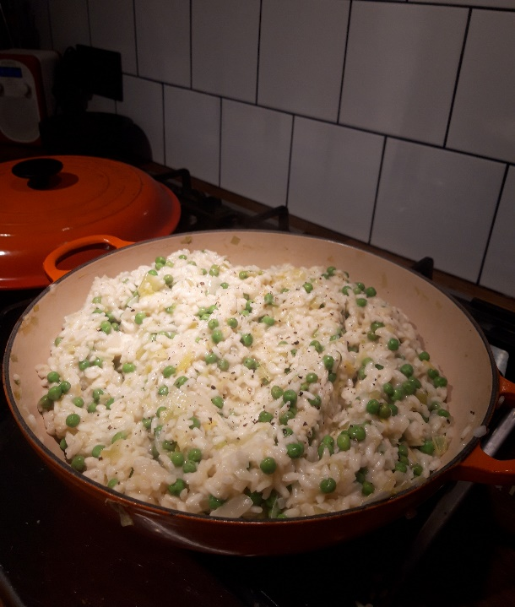

Ingredients per person
2 tbsp butter
1 tbsp olive oil
1 onion, diced
2 stalks celery, sliced
2 leeks, thinly sliced
250g peas (fresh or frozen)
400g arborio risotto rice
1 litre vegetable or chicken stock
Parmesan, grated

You will need a saucepan with a lid, a jug, a ladle and a wooden spoon

Serves 4

Method
1. Wash and finely chop the onion, celery and leeks.
2. Heat 1 tbsp butter and 1 tbsp oil in a saucepan. Add the chopped vegetables.
3. Cook on a gentle heat for around 5 minutes until the onion is beginning to go translucent.
4. Heat the stock, either in a microwave or a small pan.
5. Add the rice to the vegetables and cook for 2-3 minutes stirring constantly.
6. Add a ladle of the hot stock to the vegetables and rice and stir until the liquid is absorbed.
7. Continue to add ladles of stock, stirring frequently. Expect this to take 15-20 minutes. If you need more liquid you can add a little boiling water.
8. When most of the stock has been used up add the peas. Cook until the rice is soft but still has a slight bite.
9. Take the pan off the heat and add the remaining tablespoon of butter and a handful of parmesan. Stir and then put the lid on and leave for 5 minutes.
10. Serve with extra parmesan if desired.

