Botanic Cottage Community Cook Club 12th August 2020

Tiffin

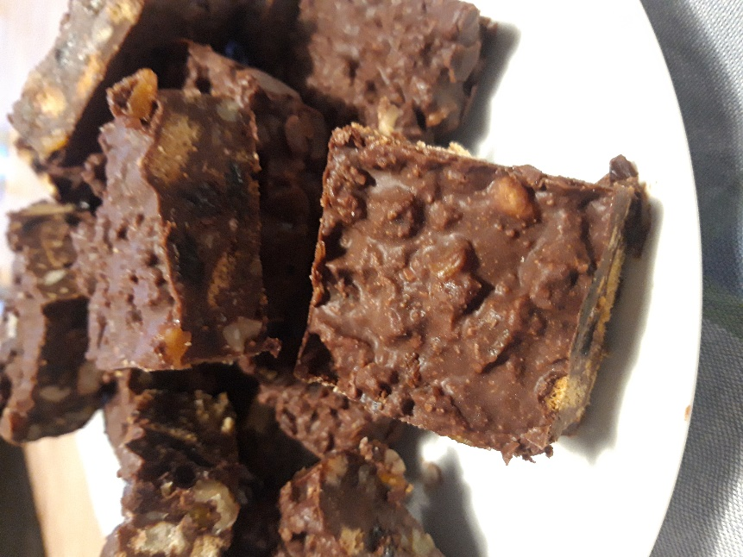
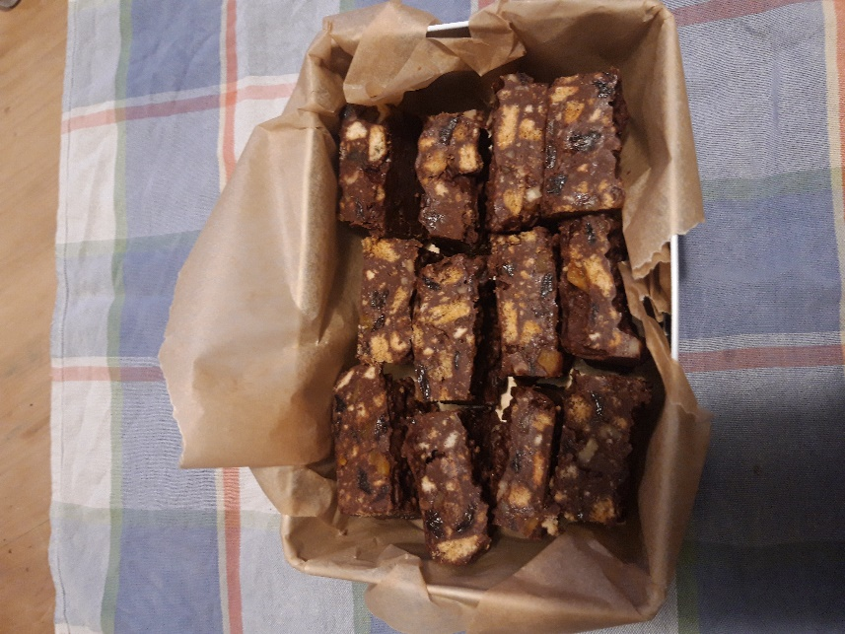

Ingredients
300g biscuits (digestives, ginger nuts and rich tea are all good- I like a mixture)
300g dark chocolate
100g dried apricots, chopped
100g raisins or sultanas
50g walnuts, chopped
100g unsalted butter
150g golden syrup or honey

You will need a small baking tin, baking paper, 2 bowls (one heatproof), a spatula, a small pot for water.
Makes about 16

Method
1. In a large bowl break up the biscuits with a rolling pin. It’s fine to leave some slightly bigger pieces. Add the chopped apricots, raisins and walnuts.
2. In a glass bowl sitting over simmering water, gently melt the butter, chocolate and golden syrup. Stir frequently until you have a dark glossy mixture.
3. Add the chocolate mixture to the biscuit mix and stir until everything is combined and covered in chocolate.
4. Pour the mixture into your baking tin and smooth the top.
5. Chill in the fridge for at least an hour until completely firm.
6. Cut into pieces. These will keep in an airtight container for about 5 days - if they last that long!

