Botanic Cottage Community Cook Club 14th Sept 2020
Apple and cinnamon swirls

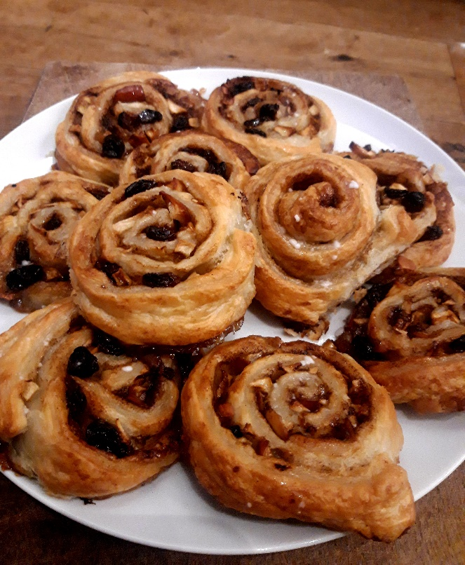

Ingredients
1 eating apple
2 tbsp soft butter
2 tbsp soft brown sugar
1 tsp ground cinnamon
1 sheet puff pastry ( 350-400g)
3 tbsp raisins or sultanas
2 tbsp milk

You will need a baking tray and baking paper, a small bowl, a chopping board and knife

Makes ten.

Method
1. Preheat the oven to 200 degrees.
2. In a small bowl, mix together the butter, sugar and cinnamon.
3. Roll open the pastry sheet and spread the sugary butter all over the pastry leaving a one inch border at one of the short ends.
4. Chop up the apple into small dice- the pieces should be about the size of a raisin. There’s no need to peel the apple.
5. Scatter the apple pieces and raisins evenly across the pasty.
6. Starting from one short end (the edge without the clear border), carefully roll up the pastry. Using a clean fingertip or a pastry brush spread a little milk on the final edge and press together.
7. Cover the baking tray in a sheet of baking paper (often the pre-rolled sheets come with paper, it’s fine to use this).
8. Carefully cut the rolled up pastry into ten roughly equal slices and place each flat on the baking tray so they look like little spirals. Leave some space between the swirls.
9. Dab a little milk over the pastries.
10. Bake for 15-20 minutes until golden and a little risen.

