Botanic Cottage Community Cook Club 14th Sept 2020
Courgette, lemon and basil pasta

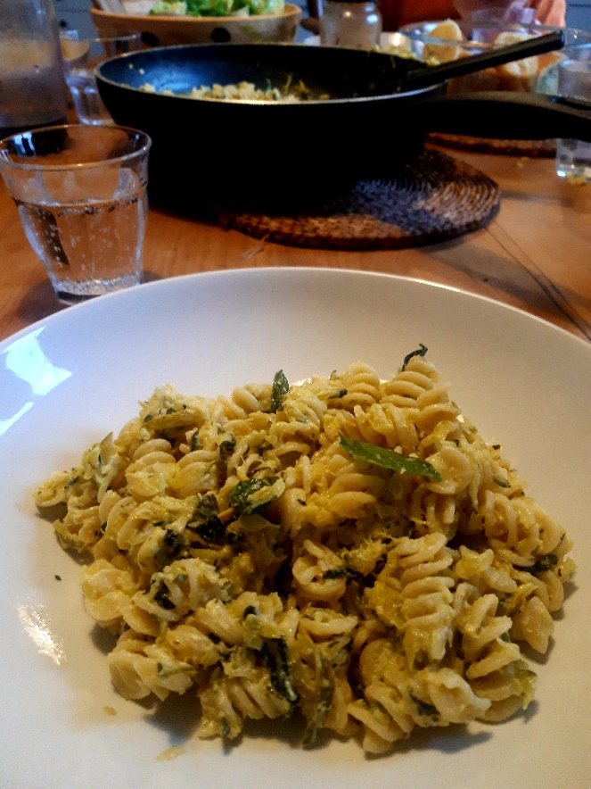

Ingredients
3-4 courgettes
1 tbsp olive oil
3 cloves garlic, peeled and sliced
200g crème fraîche
½ a lemon
Handful fresh basil leaves, roughly chopped
Handful grated parmesan
400g pasta, any type
Salt and pepper

You will need a grater, a chopping board, a large saucepan for pasta plus a wok or saucepan

Serves 4

Method
1. Grate the courgettes. It will look like an enormous amount but don’t worry!
2. Heat 1 tbsp olive oil in your wok or saucepan and add all of the courgettes plus a pinch of salt. On a low heat cook the courgettes slowly for about twenty minutes. At first there will be a lot of liquid but this will cook off as courgettes will collapse.
3. Add the garlic and keep cooking for another ten minutes.
4. Meanwhile cook your pasta in plenty of salted boiling water. Cook for slightly less than the packet says and then taste it.
5. Drain the pasta reserving a little pasta water (see below).
6. Add the crème fraîche to the courgettes and heat gently.
7. Turn off the heat and add a squeeze of lemon, some black pepper, half of the basil and all of the parmesan. Stir and then taste the sauce, adding more lemon, salt or pepper to taste.
8. Add the pasta to the sauce. If it is very thick, add a little of the reserved pasta water.
9. Top with the rest of the basil and a little more parmesan if you like.

Top tip- any time you make pasta, pop a mug in the sink to catch some of the starchy pasta water. If you need to loosen your pasta sauce- add the pasta water a tablespoon at the time until the consistency is perfect.

