Botanic Cottage Garden Social September 2020
Making your own harvest decorations
I kept mine really simple. Feel free to create something to your own design and that represents harvest for you. I chose the moon and vegetables as my theme.
Here is what I created and here is how I created it.
Resources I used:
Paper or card- I used watercolour paper
Plate or something circular– to draw around
Paint- I used watercolour paint
Paint brushes
Garden magazines/ seed catalogues
Scissors
Glue

Method

- Draw around a plate onto some paper or card (I used a side plate to draw around and drew onto watercolour paper). This represents the harvest moon.

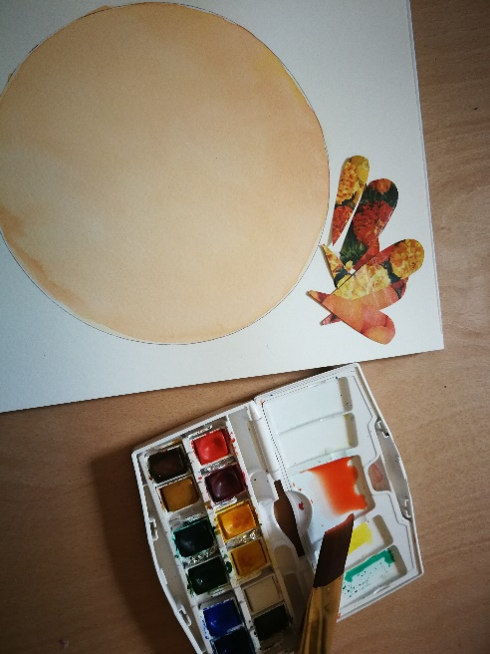

- Using some paint and a paintbrush, apply paint inside the circle. Let it dry. You could also cut out the background from a coloured piece of paper instead of painting it.

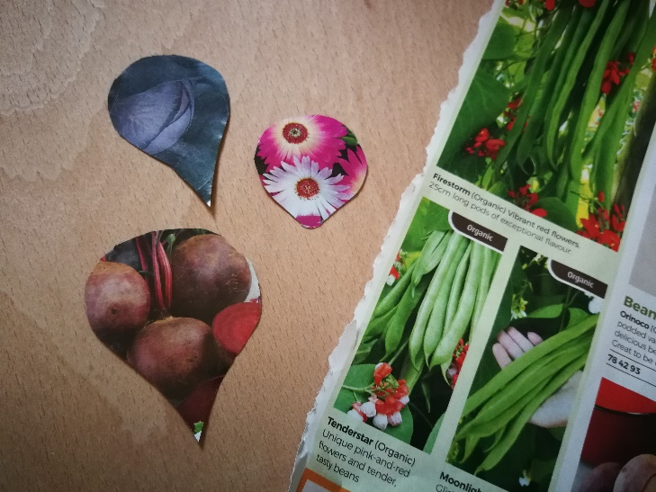

- Cut out shapes from the magazines- I cut out some carrot and beetroot shapes from appropriately coloured sections of the garden catalogue.

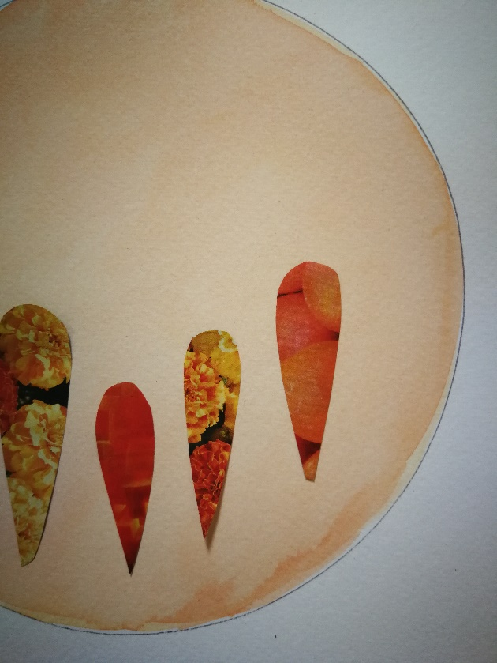

- Glue the paper shapes to your background in whatever layout you like.

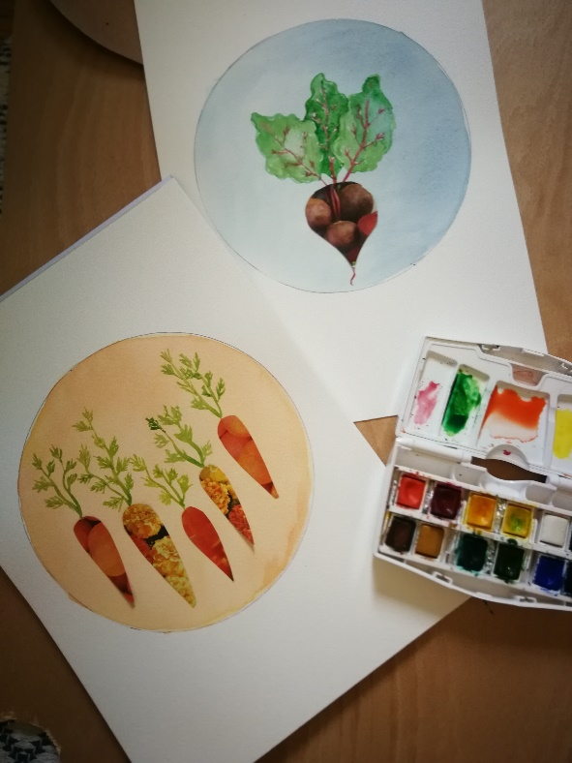

- Add detail using pens, paint, pencils- I painted on leaves of the carrot and beetroot.

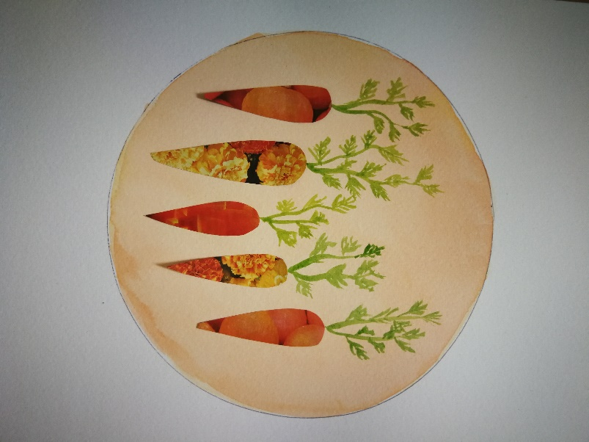

6. Hang and enjoy your artwork

