Botanic Cottage Community Cook Club 14th Sept 2020
Sage fried eggs with garlicky broccoli

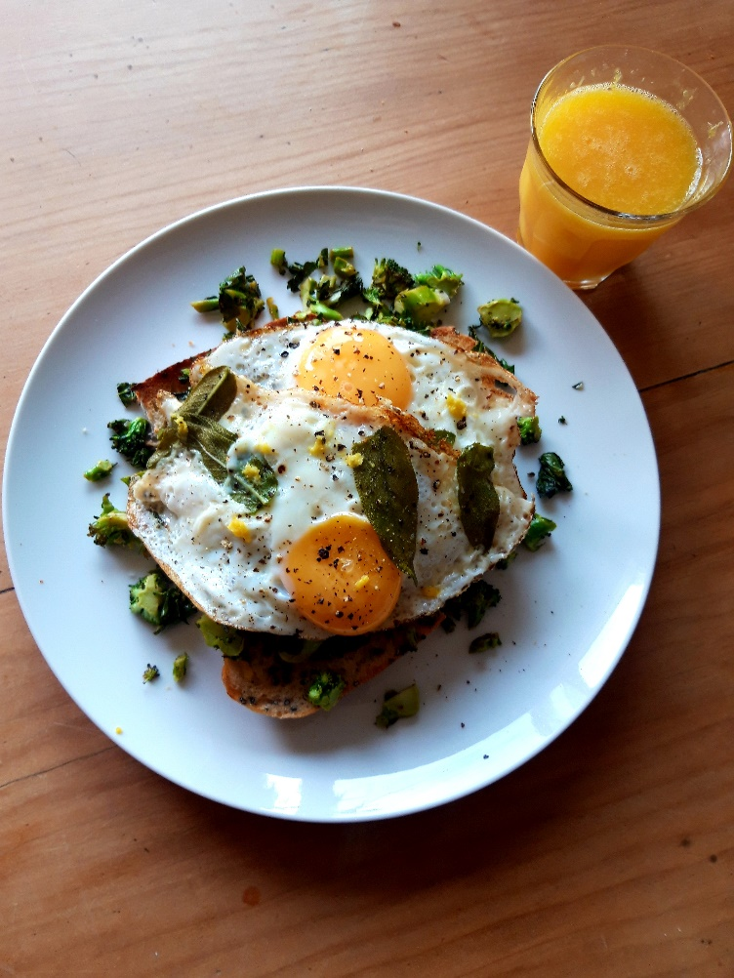

Ingredients – per person
A handful of broccoli florets
2 cloves of garlic, peeled and sliced
2 tbsp oil
½ a lemon
1-2 eggs
5-6 fresh sage leaves
A slice of toast
Salt and pepper

You will need a frying pan, a chopping board, knife and a grater

Method
1. Chop the broccoli into small pieces, it’s good to include the stalks as long as they aren’t too woody, and any leaves too.
2. Grate the lemon zest and put to one side.
3. Heat 1 tbsp oil and add the garlic slices. Cook for 30 seconds and then add the broccoli pieces. Keep the broccoli moving around the pan for about 5 minutes. It’s good to have some crispy bits but you don’t want it to burn. Squeeze the lemon half over the broccoli and season with a little salt.
4. Make your toast and top it with the broccoli.
5. Add the second tablespoon of oil and add the sage leaves. Cook for 30 seconds until getting a little crispy.
6. Break the eggs into the pan and fry until the whites are firm and the yolks are runny- or however you like your eggs!
7. Top the broccoli toast with the fried eggs, a sprinkle of lemon zest and some black pepper.

