Botanic Cottage Community Cook Club 14th Sept 2020
Squash and feta bulgur salad

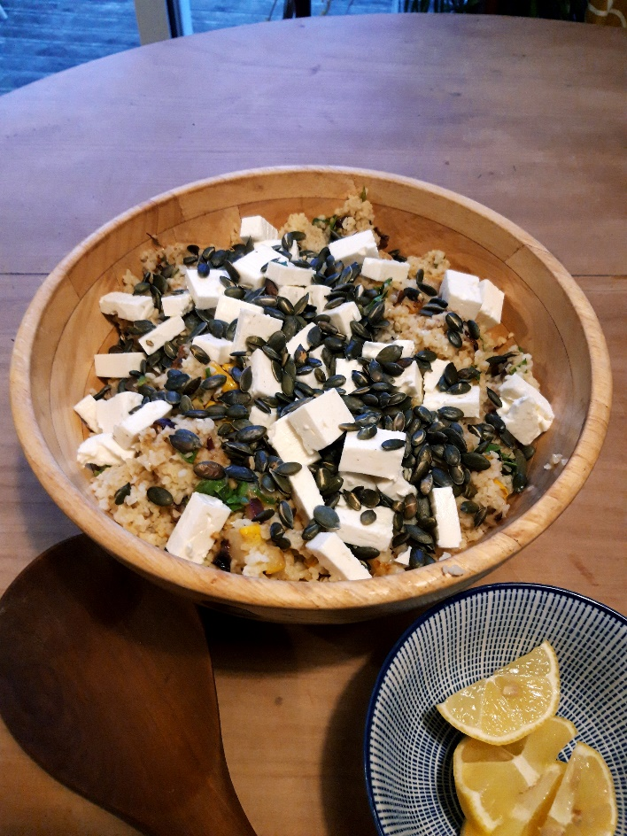

Ingredients
500-600g squash- any variety
1 red onion, diced
1 tsp smoked paprika
250g bulgur wheat
1 litre vegetable stock (made with a stock cube is fine)
1 lemon
2 large handfuls of chard or spinach, washed and roughly chopped
200g feta cheese, diced
100g pumpkin seeds
Olive oil, salt and pepper
Handful fresh coriander (optional)

You will need a baking tray, a pot, a small frying pan, a large serving bowl.

Serves 4.

Method
1. Heat the oven to 200 degrees.
2. Dice the squash (no need to peel unless very thick) and the onion. Discard the seeds. Toss with a little olive oil, 1 tsp paprika and a pinch of salt. Roast in the oven for about half an hour until the squash is tender.
3. In a pot, bring 1 litre of stock to the boil. Add the bulgur wheat and cook for ten minutes until tender. Drain any excess liquid off and keep warm.
4. Wash and roughly chop the greens.
5. In a small frying pan toast the pumpkin seeds for a few minutes shaking the pan frequently. Put to one side.
6. Briefly wilt the greens in the frying pan.
7. Transfer the squash, bulgar wheat and greens to a serving bowl along with the juice of half a lemon. Taste the salad and add more salt, pepper and lemon juice as desired.
8. Top the salad with the toasted pumpkin seeds and feta plus the coriander if using.

