Botanic Cottage Community Cook Club 10th October 2020
Botanic Cottage Apple Crumble

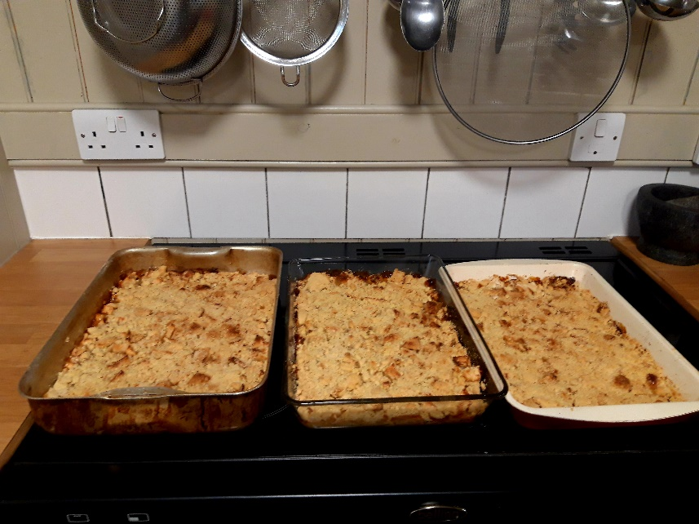

Ingredients
For the fruit
700g cooking apples- I used Bramleys
50g sugar
3 tablespoons water

For the topping
110g plain flour
50g cold butter, cubed
50g caster sugar
30g porridge oats
½ tsp ground cinnamon

Serves 6

You will need a chopping board, a peeler, a knife, a mixing bowl and an ovenproof dish

Method
1. Preheat the oven to 180 degrees.
2. Peel, core and roughly dice the apples. Arrange in an ovenproof dish. Sprinkle over 50g of sugar and 3 tablespoons of water.
3. To make the crumble topping measure out the flour and then add the cubed cold butter. Using your fingertips rub the butter into the flour until the mixture resembles breadcrumbs (alternatively pulse in a food processor). Add the sugar, oats and cinnamon and stir through.
4. Spread the crumble topping evenly over the apples.
5. Bake for around 45 minutes until the topping is golden brown and the apples are bubbling beneath.

