Botanic Cottage Community Cook Club 10th October 2020
Green split pea soup

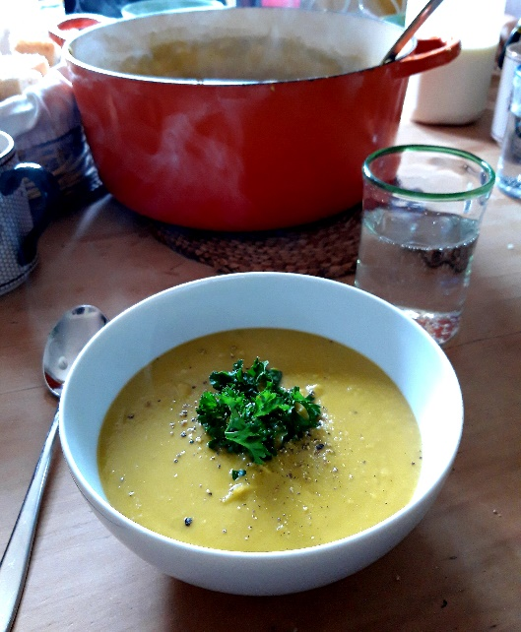

Ingredients
2 tbsp olive oil
1 large or 2 small onions
1 large or 2 small leeks
1 carrot
2 stalks celery
4 cloves garlic
500g dried green split peas, rinsed
1 litre vegetable, chicken or ham stock
1 bay leaf
½ tsp dried thyme (optional)
Salt and pepper
parsley, to serve (optional)

Serves 4, generously

You will need a large saucepan with a lid, a wooden spoon, a chopping board and a knife and a hand-blender.

Method
1. Wash and roughly chop all the vegetables, peel if necessary.
2. In a large heavy-bottomed saucepan heat the olive oil, add the onions and a pinch of salt and cook gently for five minutes until starting to soften.
3. Add the rest of the vegetables along with the bay leaf and thyme if using. Continue to cook gently for a further five minutes with a lid on.
4. Add the rinsed green split peas and the stock. Bring to a boil and boil for a few minutes.
5. Reduce the heat to a simmer and continue to cook for 45-60 minutes. You want the peas to be entirely soft, how long this takes depends on how dried your peas are. You may need to add a little more water as it cooks, keep an eye on it.
6. Carefully remove the bay leaf.
7. Using a stick-blender, blend the soup until smooth. Like with all soups made with pulses you may have to add more water. Season to taste.
8. Serve with some chopped parsley on top and some warm bread.

