Botanic Cottage Community Cook Club 10th October 2020
Perfect porridge with poached plums

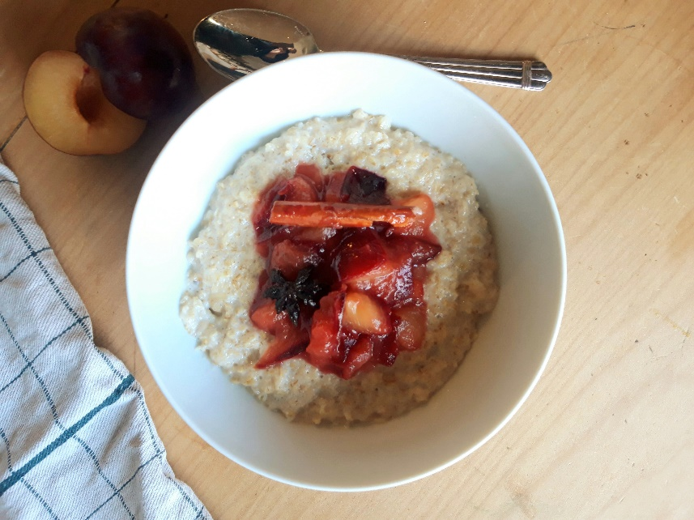

Ingredients
Porridge
Per person

½ mug porridge oats
½ mug milk
½ mug water
Tiny pinch salt

Poached plums
6 plums
1 cinnamon stick, or 1 tsp ground cinnamon
2 star anise (optional)
200ml water
3 tsp honey

Makes 4 servings

You will need two pots and two wooden spoons.

Method
1. Start with the poached plums. Wash and destone the plums and roughly chop them, there’s no need to peel them. Put the plums in a pot with the water, honey, cinnamon and star anise.
2. Cook over a medium heat for about ten minutes, stirring regularly until the plums are very soft and starting to fall apart. Add a splash more water if the mixture gets too dry.
3. Meanwhile make your porridge- add the oats, water, milk and a tiny pinch of salt to your other pot and bring to a simmer, stirring frequently. After about five minutes you will have a creamy porridge. Oats differ so carefully taste to make sure they are cooked to your liking.
4. Remove the cinnamon stick and star anise from your plums.
5. Serve your porridge with a generous scoop of poached plums and enjoy.

