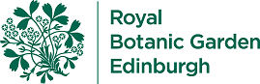

Botanic Cottage Community Cook Club 10th October 2020
Triple veg macaroni cheese

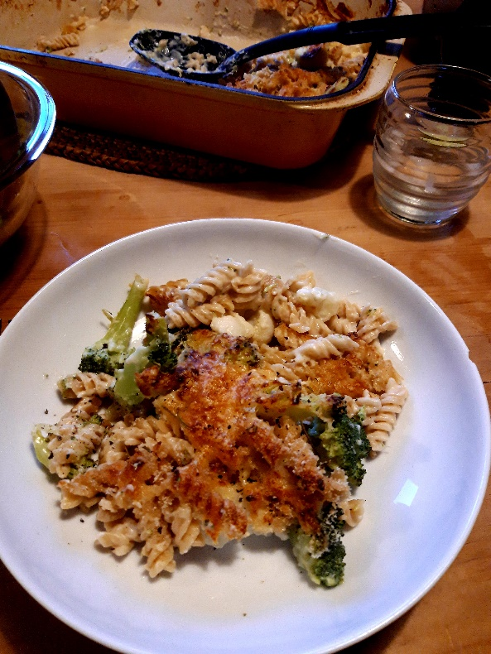

Ingredients
350g macaroni or other pasta
1 heaped tbsp butter
1 tbsp olive oil
1 heaped tbsp plain flour
600ml milk
1 leek, washed and finely sliced
1 head broccoli, broken/sliced into small florets
1 head cauliflower, broken/sliced into small florets
150g cheddar, grated plus a little extra for the top
2 tbsp grated parmesan, optional
3 tbsp breadcrumbs
salt and pepper

Serves 4

You will need two pans, a colander, a large oven dish, a jug, a wooden spoon or whisk

Method
1. Preheat the oven to 180 degrees.
2. Bring a large pan of water to the boil, add a generous pinch of salt and cook the pasta for six minutes.
3. Add the broccoli and cauliflower to the pasta and cook for two more minutes. Drain reserving half a mug of starchy pasta water.
4. Meanwhile make your cheese and leek sauce. Wash and finely chop the leek into thin slices. Heat the butter and olive oil and add the leek. Cook gently for 3-4 minutes until the leek is softening.
5. Add the flour and stir to make a thick paste with the butter and leeks. Continue to cook for one minute.
6. Start adding the milk a little at a time, stirring to incorporate and thicken. Keep going until you have used all the milk. Cook for 5 minutes more until the sauce is thick and creamy.
7. Add the grated cheddar and stir until melted. Taste for seasoning and add salt and pepper if needed.
8. Add the pasta, broccoli and cauliflower to the cheese sauce and then transfer to an oven dish. You want the sauce to be generously coating the pasta. If it seems a bit dry then you can add some of the reserved pasta water or a little more milk.
9. Top the pasta with the breadcrumbs, parmesan or extra grated cheddar.
10. Bake in the oven for 20-30 minutes until golden and bubbling

